Submit request to book Conciliation Conference

Portal Quick Reference Guide

|  |
| --- |
| Purpose |
| Quick Reference Guide shows how to: Submit request to book Conciliation Conference |

1. From Home page, click: Children’s Court of Victoria

Select a Case Type screen displays:

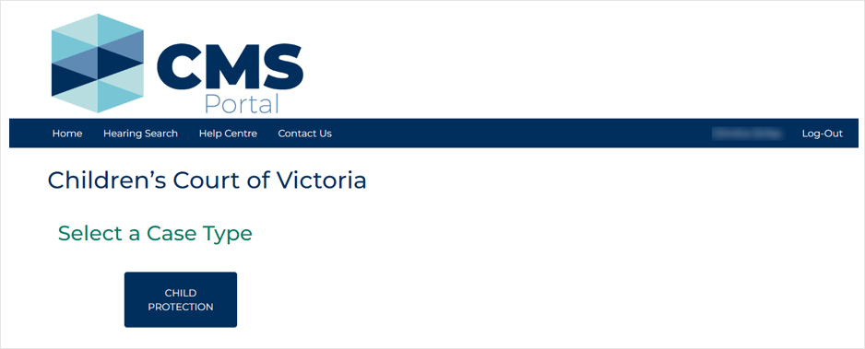

1. Click: Child Protection

Child Protection screen displays:

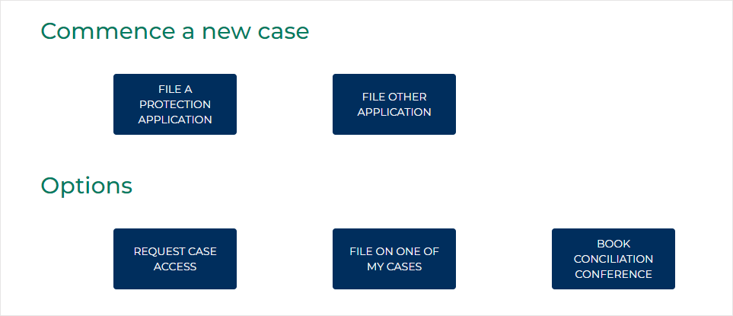

1. Click: Book Conciliation Conference

Book Conciliation Conference screen displays:

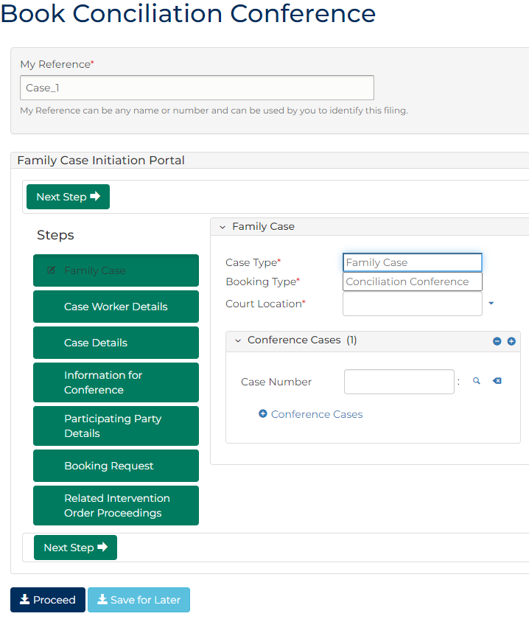

1. To identify filing, type reference in My Reference field.
2. Complete required panels and fields.

| Panel: Family Case Initiation Panel | |
| --- | --- |
| Field: | Action: |
| Case Type | - |
| Booking Type | - |
| Court location | Select location. |
| Case number | Type case number or child's name and select from results.  Note:  To add sibling, click: + Conference Cases |

1. Click: Next Step
2. Complete required panels and fields.

| Panel: Family Case Initiation Panel | |
| --- | --- |
| Field: | Action: |
| Child Protection Worker | Type applicant’s surname into search field.  Select correct option from auto-results. |
| Child Protection Worker Team Leader | Type team leader's surname into search field.  Select correct option from auto-results. |

1. Click: Next Step
2. Complete required panels and fields.

| Panel: Case Details | |
| --- | --- |
| Field: | Action: |
| Are any of the children currently place in Out of Home Care or Secure Welfare? | Select relevant option. |
| What is the family's cultural background? | Select relevant option. |

1. Is an Aboriginal and/or Torres Strait Islander cultural background selected?

|  |  |
| --- | --- |
| If | Then |
| Yes | Go to next step |
| No | Go to step 12 |

1. Complete required panels and fields.

| Panel: Case Details | |
| --- | --- |
| Field: | Action: |
| Has an Aboriginal Family Led Decision Making occurred? | If Yes, no action required.  If No, provide reason field appears  If Scheduled, date field appears |
| Has a Cultural Plan been prepared in this matter? | If Yes, no action required.  If No, provide reason field appears. |

1. Is cultural background either:   
   •    Neither Aboriginal nor Torres Strait Islander origin  
   •    Not stated/inadequately described

|  |  |
| --- | --- |
| If | Then |
| Yes | Go to next step |
| No | Go to step 14 |

1. Complete required panels and fields.

| Panel: Case Details | |
| --- | --- |
| Field: | Action: |
| Please provide family's cultural background | Type cultural background. |

1. Click: Next Step
2. Complete required panels and fields.

| Panel: Information for Conference | |
| --- | --- |
| Field: | Action: |
| Outline the areas of dispute | Type areas of dispute. |
| Does any party present with any issues that may affect their capacity to participate in the conference? | Select relevant option.  Note:  If Yes, type required details in Please provide details field. |
| Are there any safety or security concerns? | Select relevant option.  Note:  If Yes, type required details in Please provide details field. |
| Any other issues the Convenor should be aware of? | Select relevant option.  Note:  If Yes, type required details in Please provide details field. |
| Have the relevant reports been filed with the Courts? | Select Yes or No  Note:  If No, type required details in Please provide details field. |

1. Click: Next Step
2. Complete required panels and fields.

| Panel: Participating Party Details | |
| --- | --- |
| Field: | Action: |
| Participating Party Details | Type parties' contact details. |

1. Click: Next Step
2. Complete required panels and fields.

| Panel: Booking Request | |
| --- | --- |
| Field: | Action: |
| What date/date range are parties seeking? | Type date or date range. |
| Please provide reason(s) if parties are seeking a lengthy adjournment period (more than six weeks) | Type details if required. |
| Convenor preference for Aboriginal and/or Torres Strait Islander family | If the family is ATSI, please indicate parties' preference whether to have the matter listed before a Koori Convenor (provide supporting reasons) or non-Koori Convenor. |

| Panel: List any unsuitable days/dates for | |
| --- | --- |
| Field: | Action: |
| Child Protection Worker/Team Manger | Type any unsuitable days or dates. |
| Parents/Guardians | Type any unsuitable days or dates. |
| Independent Child's Lawyer (ICL) | Type any unsuitable days or dates. |
| Legal Representatives | Type any unsuitable days or dates. |
| Joined Parties/Other | Type any unsuitable days or dates. |

1. Click: Next Step
2. Complete required panels and fields.

| Panel: Related Intervention Order Proceedings (1) | |
| --- | --- |
| Field: | Action: |
| Are there any related intervention order proceedings? | Select Yes or No  Notes  If Yes, additional fields display  If multiple IVOs, click: +Related Intervention Order Proceedings |

1. Click: Proceed

Confirmation of Filing screen displays:

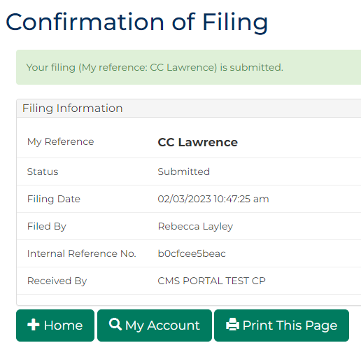

|  |  |
| --- | --- |
|  | Note:  Once tentative date is allocated, an email notification with attached Notice of Hearing is sent to DFFH and Legal Practitioners  Legal Practitioners are then required to file Minutes of Proposed Orders |
|  |  |