Manage user

Portal Quick Reference Guide

|  |
| --- |
| Purpose |
| Quick Reference Guide shows how to: Manage user |

Contents­­­

Add user 2

Modify user 6

Block user 13

# Add user

1. From CMS Portal Home page, click: Organisation Administration

Organisation Administration screen displays:

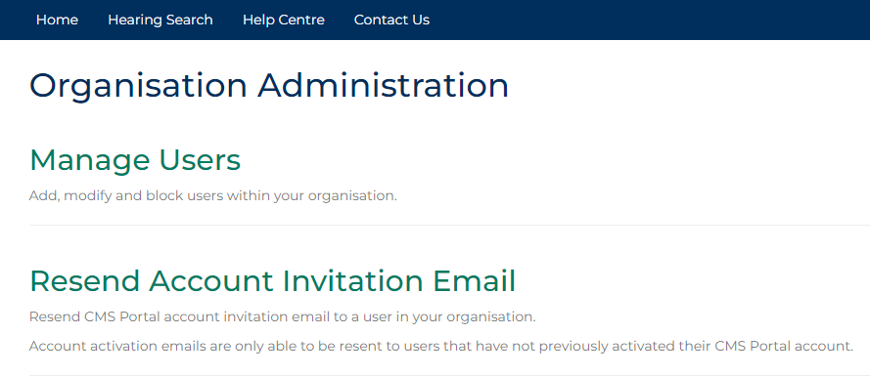

1. Click: Manage Users

People screen displays:

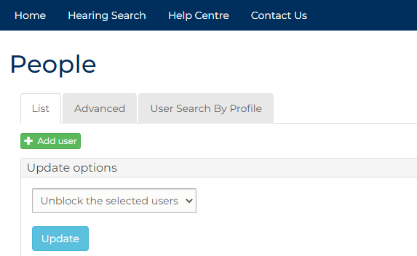

1. Click: Add User

Further fields displays:

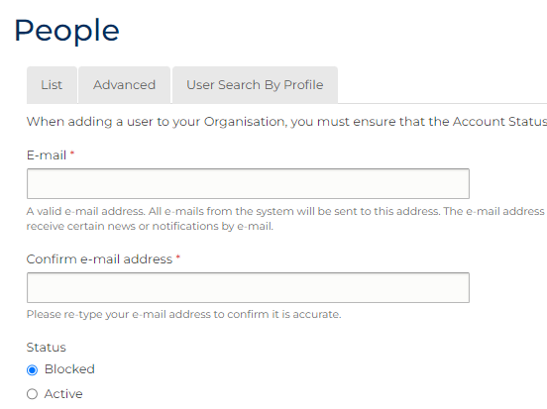

1. Complete required panels and fields.

| People | |
| --- | --- |
| Field: | Action: |
| E-mail | Type user email address. |
| Confirm e-mail address | Type user email address again. |
| Status | Select: Blocked  Note:  Account must be changed to Blocked to prompt user to acknowledge CMS terms and conditions |
| Type of User | Select user type.  Note:  Select Admin role only if another organisation administrator required. |
| Organisation | - |
| First Name | Type user first name. |
| Surname | Type user surname. |
| Unique ID Number | Type value as unique user identifier.  Note:  Number must be provided to user for account activation. |
| Secondary Email Address for All Notifications | Type additional email address to receive copies of notifications, if required. |
| Secondary Email Address for Rejections | Type additional email address to receive copies of rejections, if required. |
| Mobile Number for SMS Notifications | Type mobile number to receive SMS notifications, if required. |
| Phone Number | Type user’s preferred contact number, if relevant. |
| Fax | Type user’s fax number, if required. |
| Division | Type user’s division within organisation, if required. |
| Employee Identifier | Type Employer Identifier used internally, if required. |

1. Click: Captcha box

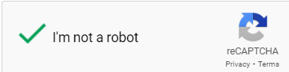

1. Click: Create new account

Confirmation message displays:

Confirmation message showing that account has been created.

|  |  |
| --- | --- |
|  | Notes:  User is sent email notification to activate account  Provide Unique ID Number to user to enter as part of activation process |

# Modify user

|  |  |
| --- | --- |
|  | Note:  This section of Quick Reference Guide shows how to:   * Modify user account * Modify user account with LLFUser access |
|  |  |

1. From CMS Portal Home page, click: Organisation Administration

Organisation Administration screen displays:



1. Click: Manage Users

People screen displays:



1. Is search with user profile details required?

|  |  |
| --- | --- |
| If | Then |
| Yes | Go to next step |
| No | Go to step 8 |

1. Click User Search By Profile tab.

Search screen displays:

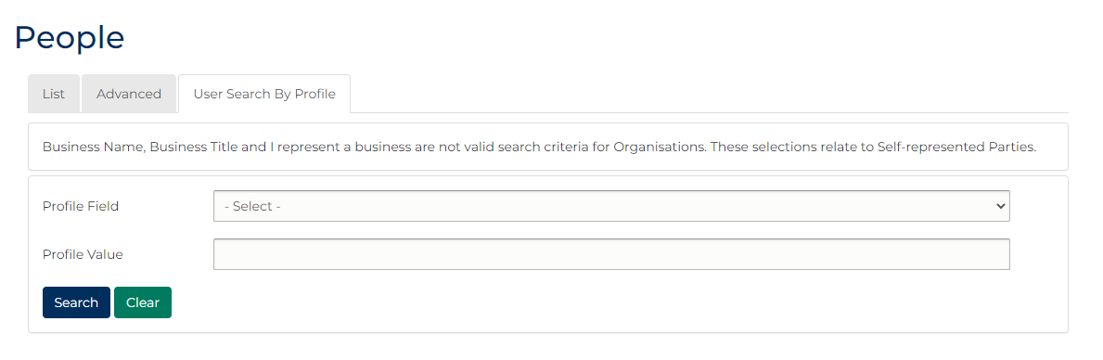

1. Complete required fields:

| Panel: User Search By Profile | |
| --- | --- |
| Field: | Action: |
| Profile Field | Select relevant option. |
| Profile Value | Type value. |

1. Click: Search

User results display:



1. Has profile been located?

|  |  |
| --- | --- |
| If | Then |
| **Yes** | Go to next step |
| **No** | Refine criteria and repeat search. |

|  |  |
| --- | --- |
|  | Note:  Select Advanced tab to perform more complex searches. |

1. Click relevant account check box.
2. In Operations column, click: edit

User My Account screen displays:

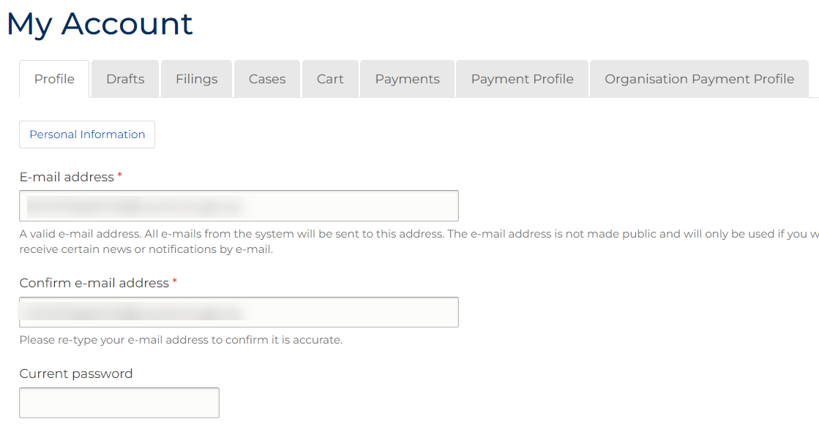

|  |  |
| --- | --- |
|  | Notes:  To see additional fields, click: Personal Information |

1. Does email address update required?

|  |  |
| --- | --- |
| If | Then |
| **Yes** | Go to next step |
| **No** | Go to step 12 |

1. Complete required panels and fields.

| User Profile | |
| --- | --- |
| Field: | Action: |
| E-mail address | Type user email address. |
| Confirm e-mail address | Type user email address again. |

1. Is password update required?

|  |  |
| --- | --- |
| If | Then |
| Yes | Go to next step |
| No | Go to step 14 |

1. Complete required panels and fields.

| User Profile | |
| --- | --- |
| Field: | Action: |
| Password | Type password. |
| Confirm password | Type password again. |

1. Is user account block required?

|  |  |
| --- | --- |
| If | Then |
| Yes | Go to next step |
| No | Go to step 16 |

1. In Status field, select: Blocked
2. Is Role, Password settings or Organisation update required?

|  |  |
| --- | --- |
| If | Then |
| Yes | Go to next step |
| No | Go to step 18 |

1. Complete required panels and fields.

| User Profile | |
| --- | --- |
| Field: | Action: |
| Roles | Change if required. |
| Force password change on next login | De-select if password change not required. |
| Organisation Name | Change if required. |

1. Click: Save

Confirmation message displays:

Confirmation message which reads: The changes have been saved.

# Block user

|  |  |
| --- | --- |
|  | Note:  This section of Quick Reference Guide shows how to Block user accounts from accessing Portal with your organisation login. |
|  |  |

1. From CMS Portal Home page, click: Organisation Administration

Organisation Administration screen displays:



1. Click: Manage Users

People screen displays:



1. From list of users on People screen, select user(s) to block.

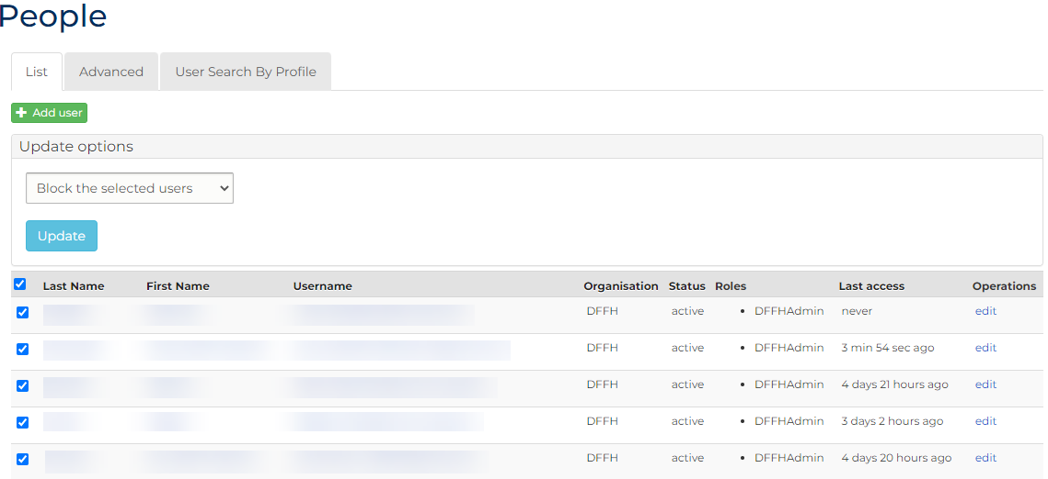

1. From Update options menu, select: Block the selected users
2. Click: Update