File Therapeutic Treatment Order (draft order)

Portal Quick Reference Guide

|  |
| --- |
| Purpose |
| Quick Reference Guide shows how to: File Therapeutic Treatment Order (draft order) |

Contents­­­

File order on application for therapeutic treatment order 2

File order on extend therapeutic treatment order subcase 17

File order on vary therapeutic treatment order subcase 25

# File order on application for therapeutic treatment order

1. From CMS Portal Home page, click: File on One of My Cases

List of cases display:

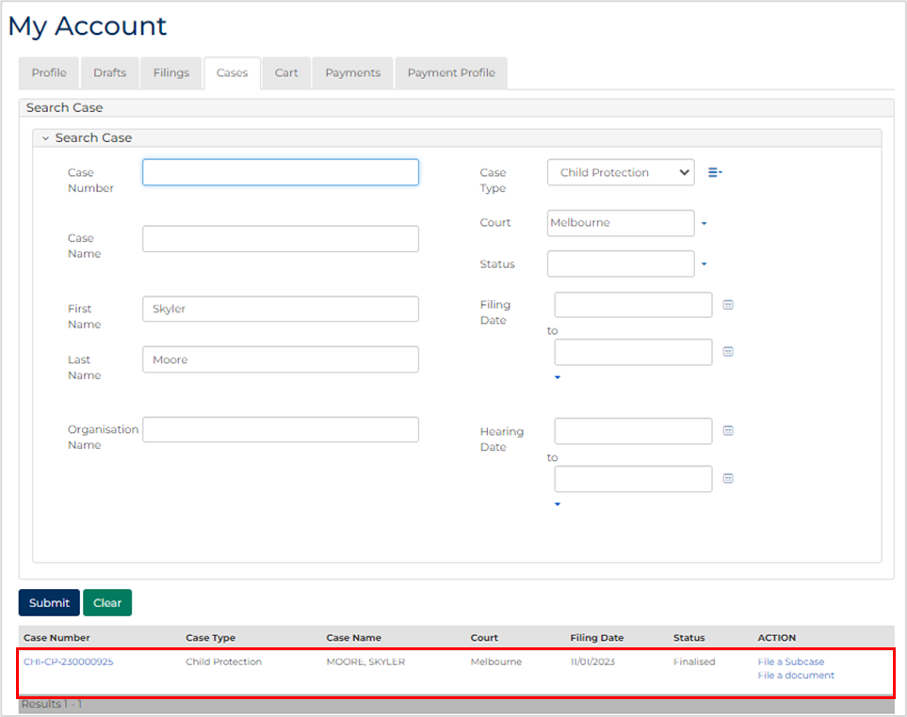

|  |  |
| --- | --- |
|  | Note:  Only cases user previously filed on or requested access to, display. |
|  |  |
|  | Resources:  See Quick Reference Guides:   * Locate and view case * Request case access |

1. For relevant case, click case number link.

Filings tab displays:

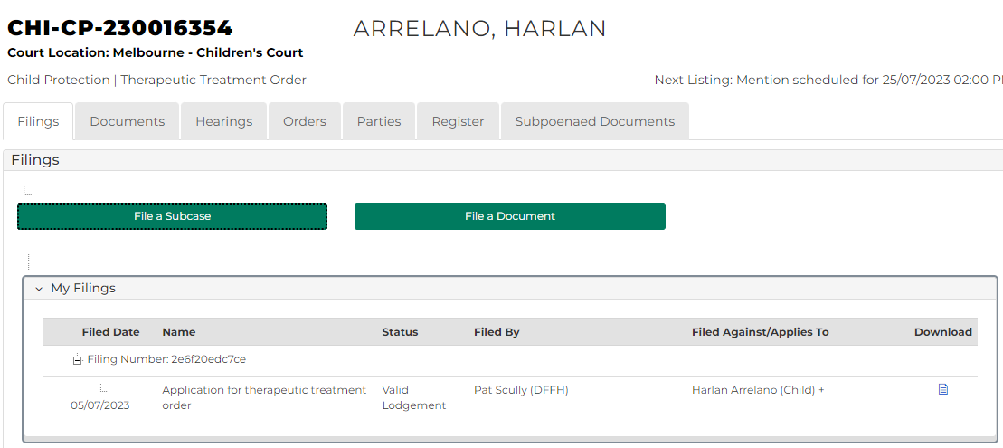

1. Click: Hearings tab.

Hearings tab displays:

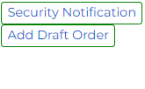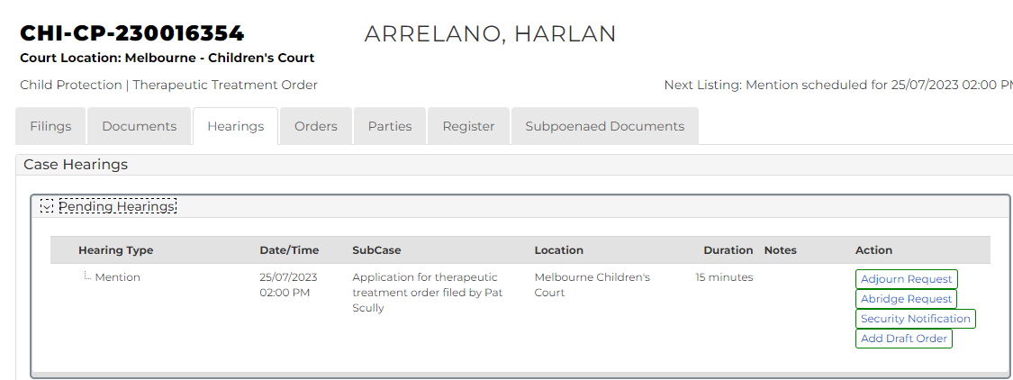

1. For relevant hearing, click: Add Draft Order

Add Draft Order screen displays:

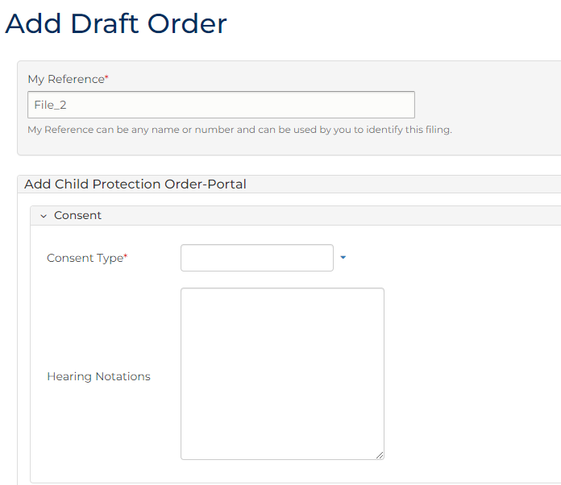

1. To identify filing, type reference in My Reference field.
2. Complete required panels and fields.

| Order Panels | |
| --- | --- |
| Panel: | Action: |
| Consent Type | Select relevant option. |
| Hearing Notations | Type if required. |
| Sub-cases | Select relevant subcase. |
| Add Order(s) | Select: Application Order |

1. Click plus icon.

Application Order panel displays:

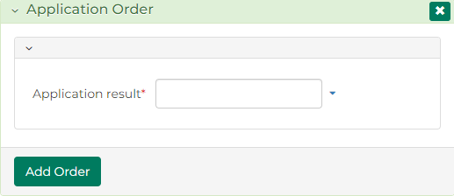

1. Is order Granted?

|  |  |
| --- | --- |
| If | Then |
| Yes | In Application Result field, select Granted  Go to next step |
| No | In Application Result field, select Refused, Dismissed or Struck Out  Go to step 11 |

1. Click: Add Order

Therapeutic Treatment Order panel displays:

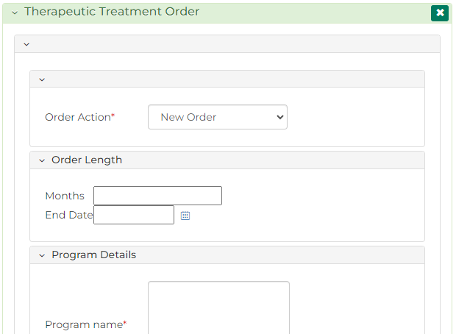

1. Complete required panels and fields.

| Panel: Therapeutic Treatment Order | |
| --- | --- |
| Field: | Action: |
| Order Action | Select: New Order |
| Months | Either:   * Type number of months in Months field * Type or use calendar icon to select date in End Date field |
| End Date |
| Program Details | Type program details. |
| Address | Type program address. |
| DFFH - TTO Report | Select if required. |
| Conditions | Select required conditions.  Note:  When condition is selected, further fields display  Select party(s) condition relates to  Click green plus icon to duplicate condition  Edit condition as required  To save conditions, click: Add Conditions  To re-order conditions, in Selected Conditions panel, click grey box and drag and drop conditions in desired order  Click red minus icon to delete condition |

1. Click: Add Order

Order Summary displays:

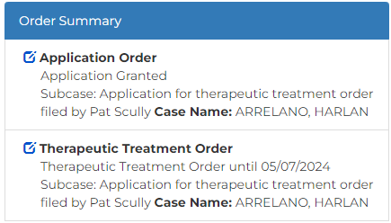

1. Is DFFH - TTO Report selected?

|  |  |
| --- | --- |
| If | Then |
| Yes | Report request order must be made  Go to next step |
| No | Go to step 18 |

1. Complete required panels and fields.

| Order Panels | |
| --- | --- |
| Panel: | Action: |
| Sub-cases | Select relevant subcase. |
| Add Order(s) | Select: Report Request |

1. Click plus icon

Report Request Order panel displays:

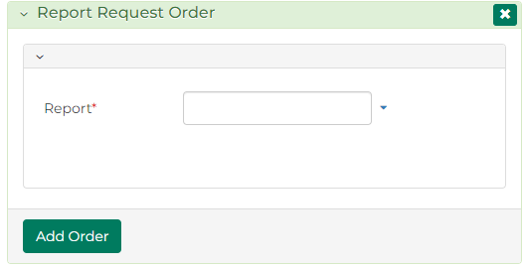

1. From Report menu, select: Therapeutic Treatment Order progress

Further fields display:

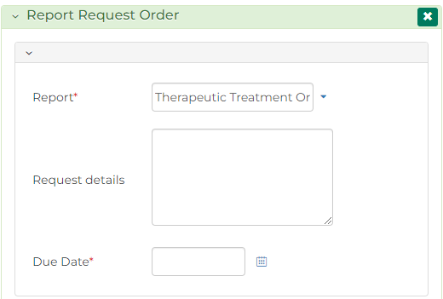

1. Complete required panels and fields.

| Panel: Report Request Order | |
| --- | --- |
| Field: | Action: |
| Request details | Type relevant details. |
| Due Date | Type or use calendar icon to select date. |

1. Click: Add Order

Order Summary displays:

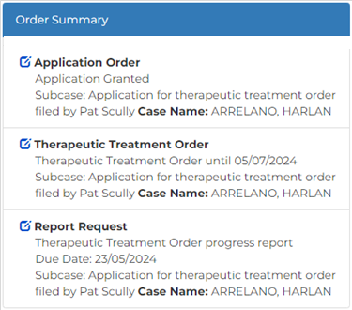

|  |  |
| --- | --- |
|  | Note:  An adjournment order must now be made. |
|  |  |

1. Complete required panels and fields.

| Order Panels | |
| --- | --- |
| Panel: | Action: |
| Sub-cases | Select relevant subcase. |
| Add Order(s) | Select: Adjournment |

1. Click plus icon

Adjournment Order panel displays:

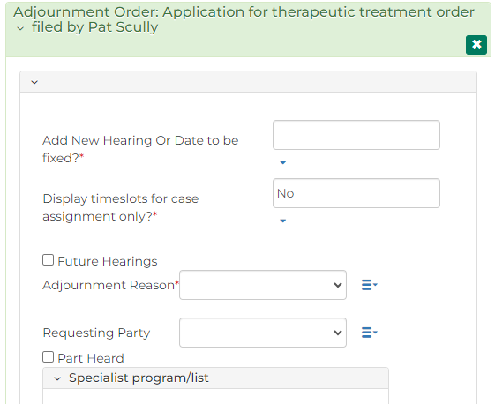

1. Complete required panels and fields.

| Panel: Adjournment Order | |
| --- | --- |
| Field: | Action: |
| Add New Hearing or Date to be fixed? | Select: New Hearing |
| Type | Select type of hearing.  Note:   * Calendar Assistant displays * Select available date from Calendar Assistant |
| Court Location | Change if required. |
| Case Jurisdiction | - |
| Display timeslots for case assignment only? | Change if required.  Note:   * Field displays Yes if case has been assigned to Judicial Officer * Field displays No if case has not been assigned to Judicial Officer |
| Start Date Time | Do not change. |
| Calendar Recurring Event Widget | Select if required.  Note:  If selected, further fields display. |
| Duration Minutes | Do not change. |

| Panel: Adjournment Order | |
| --- | --- |
| Field: | Action: |
| Future Hearings | Select if required.  Note:  If selected, further fields display. |
| Adjournment Reason | Select adjournment reason. |
| Requesting Party | Select if required. |
| Part Heard | Select if required. |
| Specialist program/list | Select if required. |

1. Click: Add Order

Order Summary displays:

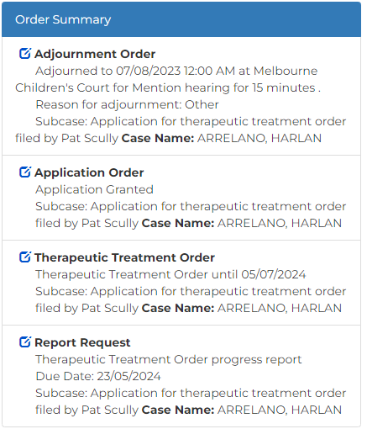

|  |  |
| --- | --- |
|  | Note:  Once all orders are added, click Preview button to review order in more detail. |
|  |  |

1. Is another order required?

|  |  |
| --- | --- |
| If | Then |
| Yes | Add order  Resource:  See Quick Reference Guide: File Minutes of Proposed Orders (Amend, Add or Delete) |
| No | Go to next step |

1. Is Order Summary correct?

|  |  |
| --- | --- |
| If | Then |
| Yes | Go to next step |
| No | Amend order  Resource:  See Quick Reference Guide: File Minutes of Proposed Orders (Amend, Add or Delete) |

1. In Share with parties or submit to court? field, select relevant option.

|  |  |
| --- | --- |
|  | Note:  Share with Parties allows other parties to view and update proposed draft order  Draft order cannot be updated once Submit to Court selected |

1. Click: Proceed

Confirmation of Filing screen displays:

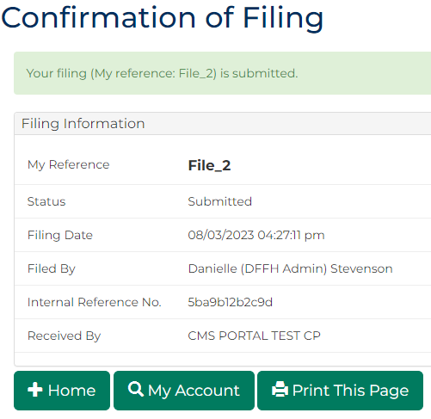

|  |  |
| --- | --- |
|  | Note:  Draft order can be updated in Orders tab any time before submission to Court  Once submitted, Minutes of proposed orders document generates and can be accessed through My Account screen |
|  |  |
|  | Resources:  See Quick Reference Guides:   * File Minutes of Proposed Orders (Amend, Add or Delete) * Download document |
|  |  |

# File order on extend therapeutic treatment order subcase

1. From CMS Portal Home page, click: File on One of My Cases

List of cases display:



|  |  |
| --- | --- |
|  | Note:  Only cases user previously filed on or requested access to, display. |
|  |  |
|  | Resources:  See Quick Reference Guides:   * Locate and view case * Request case access |

1. For relevant case, click case number link.

Filings tab displays:



1. Click: Hearings tab.

Hearings tab displays:

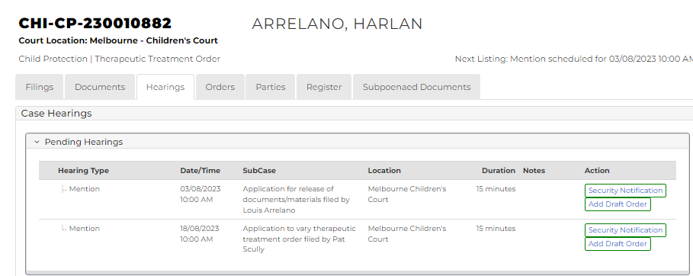

1. For relevant hearing, click: Add Draft Order

Add Draft Order screen displays:



1. To identify filing, type reference in My Reference field.
2. Complete required panels and fields.

| Order Panels | |
| --- | --- |
| Panel: | Action: |
| Consent Type | Select relevant option. |
| Hearing Notations | Type if required. |
| Sub-cases | Select relevant subcase. |
| Add Order(s) | Select: Application Order |

1. Click plus icon.

Application Order panel displays:



1. Is order Granted?

|  |  |
| --- | --- |
| If | Then |
| Yes | In Application Result field, select Granted  Go to next step |
| No | In Application Result field, select Refused, Dismissed or Struck Out  Go to step 11 |

1. Click: Add Order

Therapeutic Treatment Order panel displays:

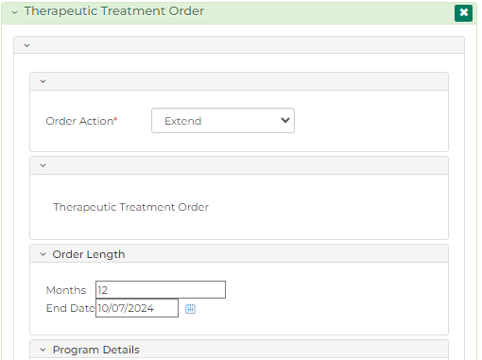

1. Complete required panels and fields.

| Panel: Therapeutic Treatment Order | |
| --- | --- |
| Field: | Action: |
| Order Action | Select: Extend |
| Months | Either:   * Type number of months in Months field   Type or use calendar icon to select date in End Date field |
| End Date |
| Program Name | Do not change. |
| Address | Do not change. |
| DFFH - TTO Report | Select if required. |
| Conditions | Do not change. |

1. Click: Add Order

Order Summary displays:

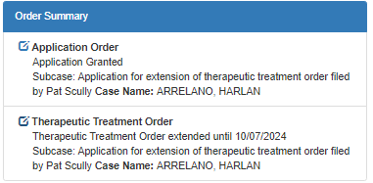

|  |  |
| --- | --- |
|  | Note:  Once all orders are added, click Preview button to review order in more detail  If DFFH - TTO Report selected, report request order must be made |
|  |  |
|  | Resource:  See first section of this Quick Reference Guide. |
|  |  |

1. Is another order required?

|  |  |
| --- | --- |
| If | Then |
| Yes | Add order  Resource:  See Quick Reference Guide: File Minutes of Proposed Orders (Amend, Add or Delete) |
| No | Go to next step |

1. Is Order Summary correct?

|  |  |
| --- | --- |
| If | Then |
| Yes | Go to next step |
| No | Amend order  Resource:  See Quick Reference Guide: File Minutes of Proposed Orders (Amend, Add or Delete) |

1. In Share with parties or submit to court? field, select relevant option.

|  |  |
| --- | --- |
|  | Note:  Share with Parties allows other parties to view and update proposed draft order  Draft order cannot be updated once Submit to Court selected |

1. Click: Proceed

Confirmation of Filing screen displays:



|  |  |
| --- | --- |
|  | Note:  Draft order can be updated in Orders tab any time before submission to Court  Once submitted, Minutes of proposed orders document generates and can be accessed through My Account screen |
|  |  |
|  | Resources:  See Quick Reference Guides:   * File Minutes of Proposed Orders (Amend, Add or Delete) * Download document |
|  |  |

# File order on vary therapeutic treatment order subcase

1. From CMS Portal Home page, click: File on One of My Cases

List of cases display:



|  |  |
| --- | --- |
|  | Note:  Only cases user previously filed on or requested access to, display. |
|  |  |
|  | Resources:  See Quick Reference Guides:   * Locate and view case * Request case access |

1. For relevant case, click case number link.

Filings tab displays:



1. Click: Hearings tab.

Hearings tab displays:



1. For relevant hearing, click: Add Draft Order

Add Draft Order screen displays:



1. To identify filing, type reference in My Reference field.
2. Complete required panels and fields.

| Order Panels | |
| --- | --- |
| Panel: | Action: |
| Consent Type | Select relevant option. |
| Hearing Notations | Type if required. |
| Sub-cases | Select relevant subcase. |
| Add Order(s) | Select: Application Order |

1. Click plus icon.

Application Order panel displays:



1. Is order Granted?

|  |  |
| --- | --- |
| If | Then |
| Yes | In Application Result field, select Granted  Go to next step |
| No | In Application Result field, select Refused, Dismissed or Struck Out  Go to step 11 |

1. Click: Add Order

Therapeutic Treatment Order panel displays:

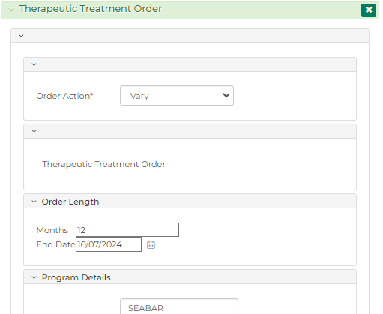

1. Complete required panels and fields.

| Panel: Therapeutic Treatment Order | |
| --- | --- |
| Field: | Action: |
| Order Action | Select: Vary |
| Months | Do not change. |
| End Date | Do not change. |
| Program Name | Change if required. |
| Address | Change if required. |
| DFFH - TTO Report | Select if required. |
| Conditions | Change if required.  Note:  When condition is selected, further fields display  Select party(s) condition relates to  Click green plus icon to duplicate condition  Edit condition as required  To save conditions, click: Add Conditions  To re-order conditions, in Selected Conditions panel, click grey box and drag and drop conditions in desired order  Click red minus icon to delete condition |

1. Click: Add Order

Order Summary displays:

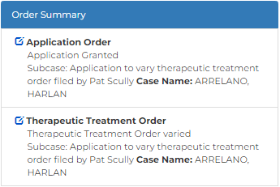

|  |  |
| --- | --- |
|  | Note:  Once all orders are added, click Preview button to review order in more detail  If DFFH - TTO Report selected, report request order must be made |
|  |  |
|  | Resource:  See first section of this Quick Reference Guide. |
|  |  |

1. Is another order required?

|  |  |
| --- | --- |
| If | Then |
| Yes | Add order  Resource:  See Quick Reference Guide: File Minutes of Proposed Orders (Amend, Add or Delete) |
| No | Go to next step |

1. Is Order Summary correct?

|  |  |
| --- | --- |
| If | Then |
| Yes | Go to next step |
| No | Amend order  Resource:  See Quick Reference Guide: File Minutes of Proposed Orders (Amend, Add or Delete) |

1. In Share with parties or submit to court? field, select relevant option.

|  |  |
| --- | --- |
|  | Note:  Share with Parties allows other parties to view and update proposed draft order  Draft order cannot be updated once Submit to Court selected |

1. Click: Proceed

Confirmation of Filing screen displays:



|  |  |
| --- | --- |
|  | Note:  Draft order can be updated in Orders tab any time before submission to Court  Once submitted, Minutes of proposed orders document generates and can be accessed through My Account screen |
|  |  |
|  | Resources:  See Quick Reference Guides:   * File Minutes of Proposed Orders (Amend, Add or Delete) * Download document |
|  |  |