File order directing child attend court (draft order)

Portal Quick Reference Guide

|  |
| --- |
| Purpose |
| Quick Reference Guide shows how to: File order directing child attend court (draft order) |

1. From CMS Portal Home page, click: File on One of My Cases

List of cases display:

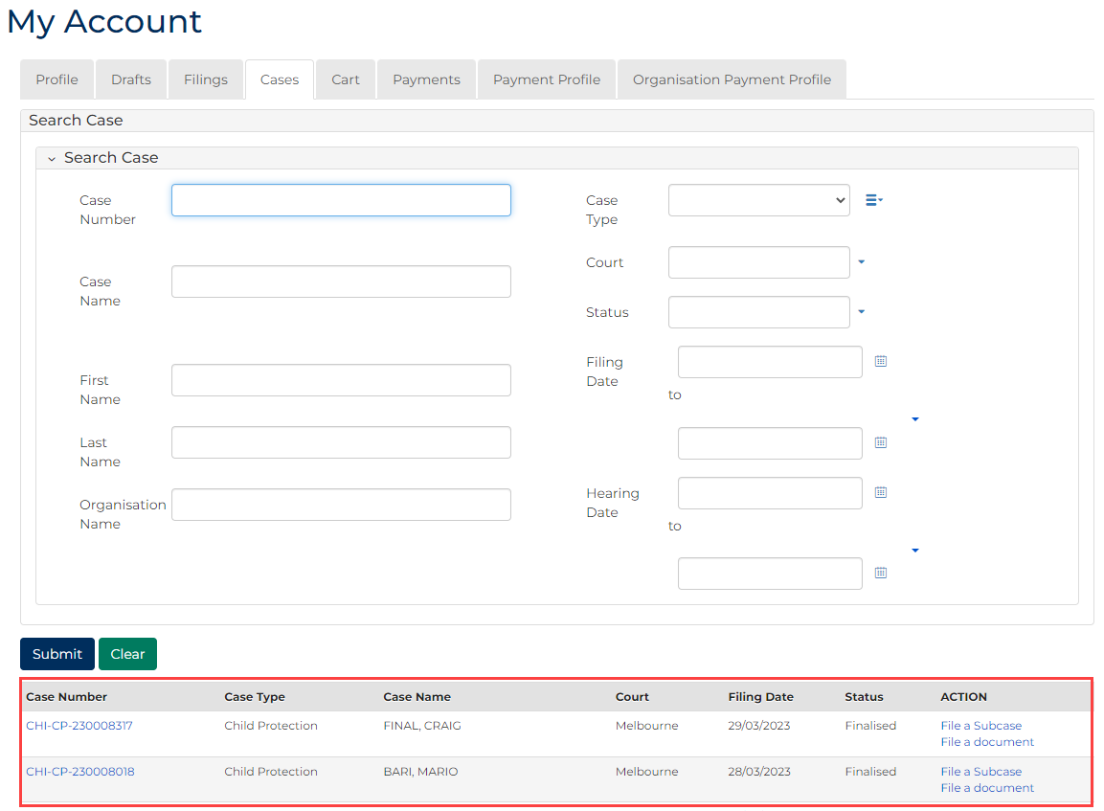

|  |  |
| --- | --- |
|  | Note:  Only cases user previously filed on or requested access to, display. |
|  |  |
|  | Resources:  See Quick Reference Guides:   * Locate and view case * Request case access |
|  |  |

1. For relevant case, click case number link.

Filings tab displays:

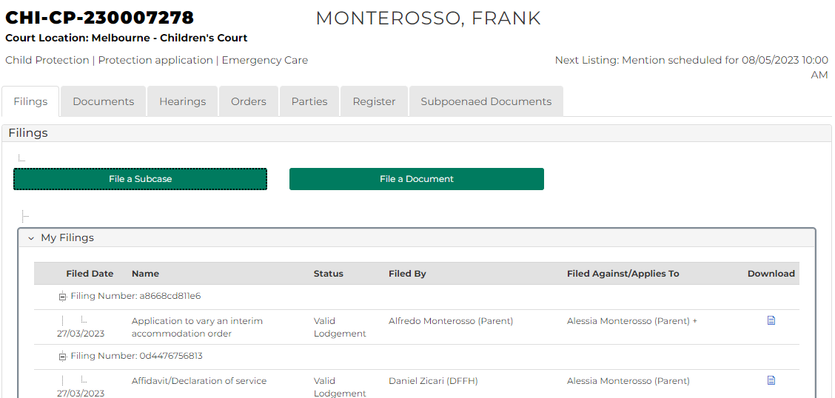

1. Click: Hearings tab.

Hearings tab displays:

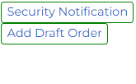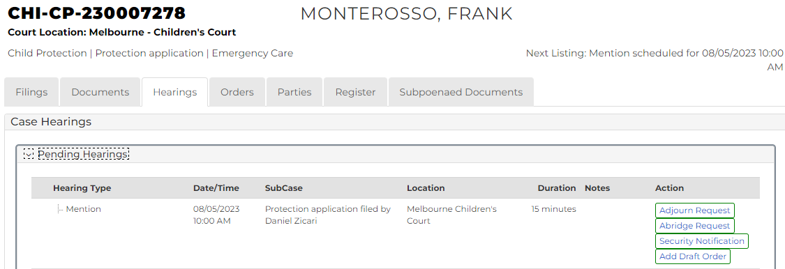

1. For relevant hearing, click: Add Draft Order

Add Draft Order screen displays:

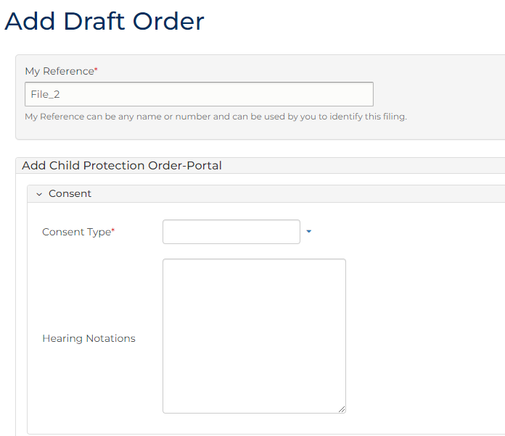

1. To identify filing, type reference in My Reference field.
2. Complete required panels and fields.

| Order Panels | |
| --- | --- |
| Panel: | Action: |
| Consent Type | Select relevant option. |
| Hearing Notations | Type if required. |
| Sub-cases | Select relevant subcase. |
| Add Order(s) | Select: Child attend Court |

1. Click plus icon.

Child Attend Court panel displays:

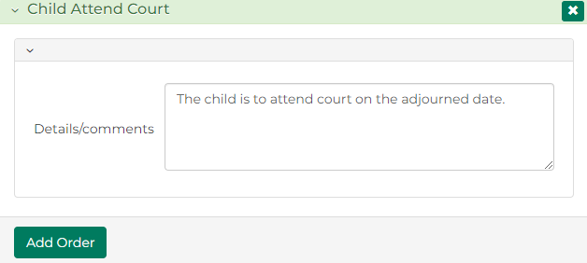

1. Review Details/comments and change if required.
2. Click: Add Order

Order Summary displays:

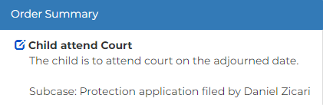

|  |  |
| --- | --- |
|  | Note:  Child attend Court order requires Adjournment order to be added. |
|  |  |

|  |  |
| --- | --- |
|  | Resource:  See Quick Reference Guide: Make Adjournment order |
|  |  |

|  |  |
| --- | --- |
|  | Note:  Once all orders are added, click Preview button to review order in more detail. |
|  |  |

1. Is another order required?

|  |  |
| --- | --- |
| If | Then |
| Yes | Add order  Resource:  See Quick Reference Guide: File Minutes of Proposed Orders (Amend, Add or Delete) |
| No | Go to next step |

1. Is Order Summary correct?

|  |  |
| --- | --- |
| If | Then |
| Yes | Go to next step |
| No | Amend order  Resource:  See Quick Reference Guide: File Minutes of Proposed Orders (Amend, Add or Delete) |

1. In Share with parties or submit to court? field, select relevant option.

|  |  |
| --- | --- |
|  | Note:  Share with Parties allows other parties to view and update proposed draft order  Draft order cannot be updated once Submit to Court selected |

1. Click: Proceed

Confirmation of Filing screen displays:

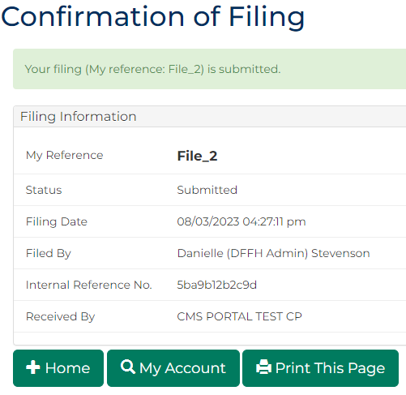

|  |  |
| --- | --- |
|  | Note:   * Draft order can be updated in Orders tab any time before submission to Court   Once submitted, Minutes of proposed orders document generates and is accessed through My Account screen |
|  |  |
|  | Resources:  See Quick Reference Guides:   * File Minutes of Proposed Orders (Amend, Add or Delete) * Download document |
|  |  |