File Long Term Care Order application

Portal Quick Reference Guide

|  |
| --- |
| Purpose |
| Quick Reference Guide shows how to: File Long Term Care Order application in CMS Portal |

1. From CMS Portal Home page, click: File on One of My Cases

List of cases display:

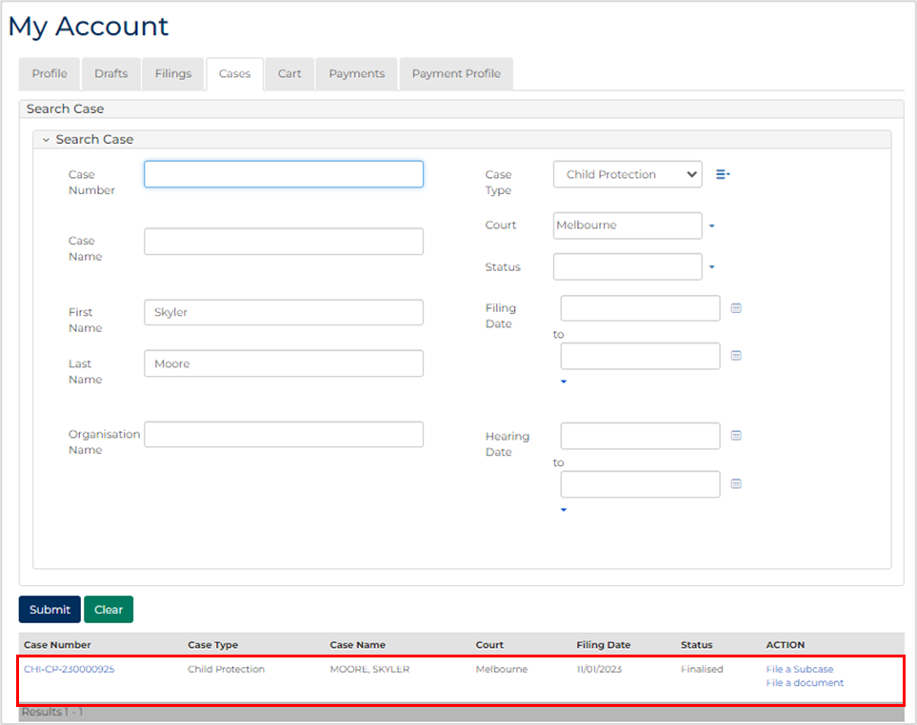

|  |  |
| --- | --- |
|  | Note:  Only cases user previously filed on or requested access to, display. |
|  | Resources:  See Quick Reference Guides:   * View and action case * Request case access |
|  |  |

1. Select: File a Subcase

Add Subcase screen displays:

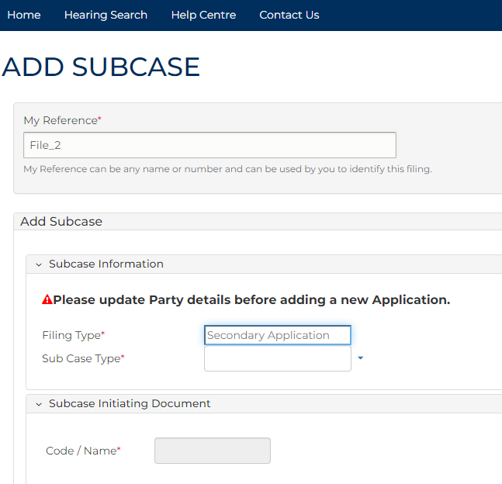

1. To identify filing, type reference in My Reference field.
2. Complete required panels and fields.

| Panel: Subcase Information | |
| --- | --- |
| Field: | Action: |
| Filing Type | - |
| Sub Case Type | Select: Long-term Care Order |
| Related Orders | - |

| Additional Panels | |
| --- | --- |
| Field: | Action: |
| Code/Name | - |
| Grounds for application | Type grounds. |
| Filed By | Select filing practitioner or type name in Add Filed By panel. |
| Applies To | Select party(s). |
| Add to Related Cases | Select related case(s) if required. |

1. Is Add New Hearing correct option?

|  |  |
| --- | --- |
| If | Then |
| Yes | Go to next step |
| No | Go to step 7 |

1. Complete required panels and fields.

| Panel: Add Hearing | |
| --- | --- |
| Field: | Action: |
| Add New Hearing | Select: Add New Hearing  Select relevant option from Calendar Assistant |
| Event Location | Change if required. |
| Hearing Type | - |
| Date & Time | Do not change. |
| Duration | Do not change. |
| Resources | Select if required |
| Interpreter | Select party requiring interpreter.  Note:  If additional party(s) require interpreter, click: + Interpreter |
| Duration | Type interpreter booking duration. |
| Interpreter Language | Select required interpreter language. |
| Is gender specific interpreter required? | Select Yes or No  Note:  If Yes, select gender. |
| Hearing Notes | Type if required. |

1. Is List with Existing Hearing correct option?

|  |  |
| --- | --- |
| If | Then |
| Yes | Go to next step |
| No | Go to step 10 |

1. In Add Hearing panel, select: List with Existing Hearing

Related Hearings panel displays:

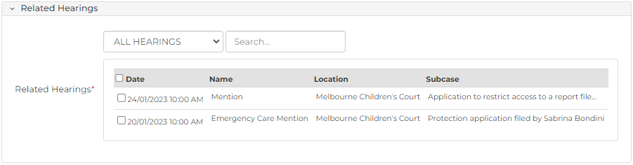

1. Complete required panels and fields.

| Panel: Add Hearing | |
| --- | --- |
| Panel: | Action: |
| Related Hearings | Select hearing to list with. |
| Resources | Select if required. |
| Interpreter | Select party requiring interpreter.  Note:  If additional party(s) require interpreter, click: + Interpreter |
| Duration | Type interpreter booking duration. |
| Interpreter Language | Select required interpreter language. |
| Is gender specific interpreter required? | Select Yes or No if required.  Note:  If Yes, select gender. |
| Hearing Notes | Type if required. |

1. Complete required panels and fields.

| Panel: Additional Documents | |
| --- | --- |
| Panel: | Action: |
| Code / Name | Type name and select additional document(s). |
| Upload Document | Click: Choose File and attach PDF document. |

1. Select Electronic Signature Consent to consent to affixing your signature to filing.
2. Click: Proceed

Confirmation of Filing screen displays:

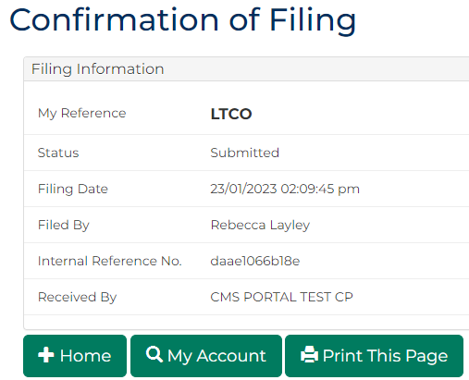

|  |  |
| --- | --- |
|  | Note:  Long Term Care application document is generated and accessed through My Account screen. |
|  | Resource:  See Quick Reference Guide: Download document |
|  |  |