File Adjournment Order (draft order)

Portal Quick Reference Guide

|  |
| --- |
| Purpose |
| Quick Reference Guide shows how to: File Adjournment Order (draft order) |

1. From CMS Portal Home page, click: File on One of My Cases

List of cases display:

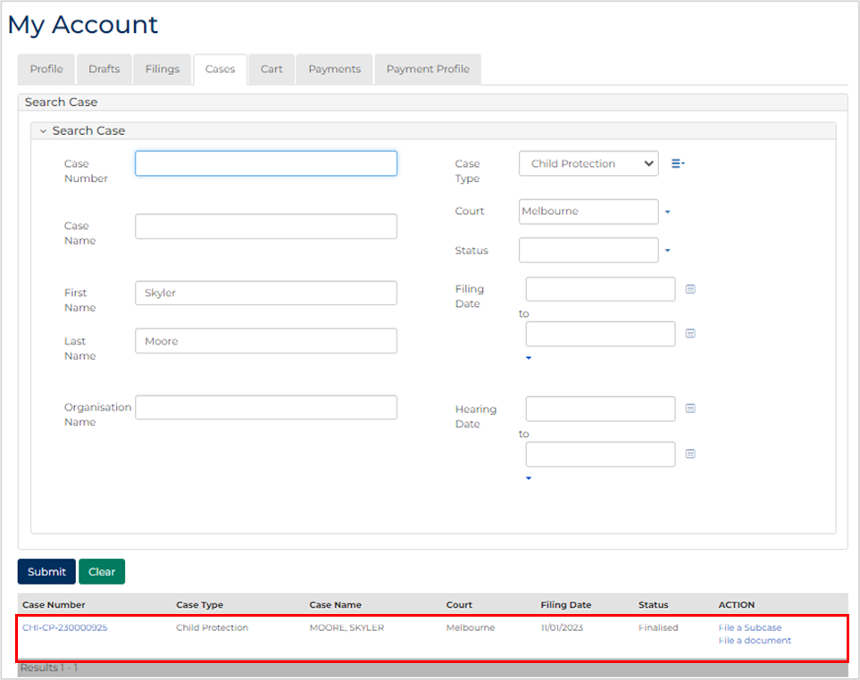

|  |  |
| --- | --- |
|  | Note:  Only cases user previously filed on or requested access to, display. |
|  |  |
|  | Resources:  See Quick Reference Guides:   * Locate and view case * Request case access |
|  |  |

1. For relevant case, click case number link.

Filings tab displays:

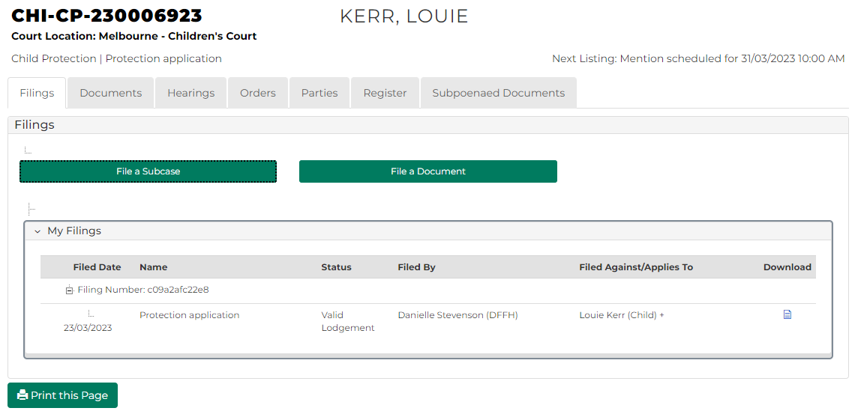

1. Click: Hearings tab.

Hearings tab displays:

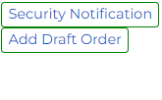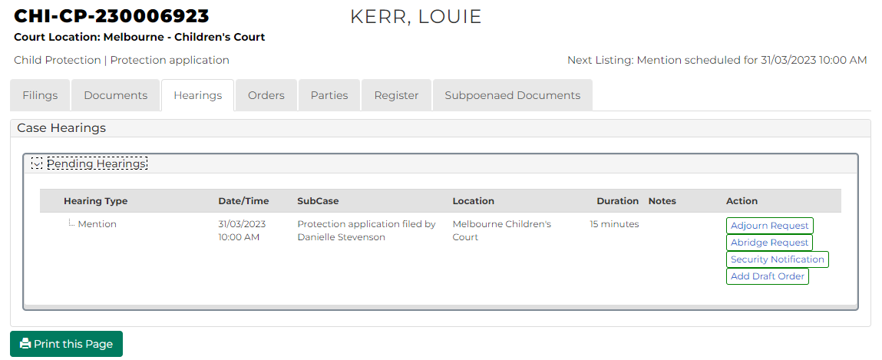

1. For relevant hearing, click: Add Draft Order

Add Draft Order screen displays:

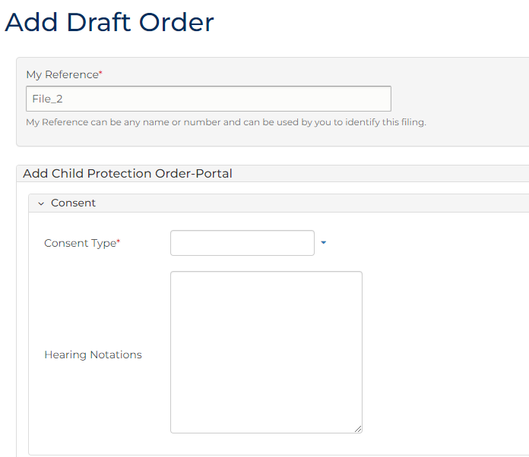

1. To identify filing, type reference in My Reference field.
2. Complete required panels and fields.

| Order Panels | |
| --- | --- |
| Panel: | Action: |
| Consent Type | Select relevant option. |
| Hearing Notations | Type if required. |
| Sub-cases | Select relevant subcase. |
| Add Order(s) | Select: Adjournment Order |

1. Click plus icon.

Adjournment Order panel displays:

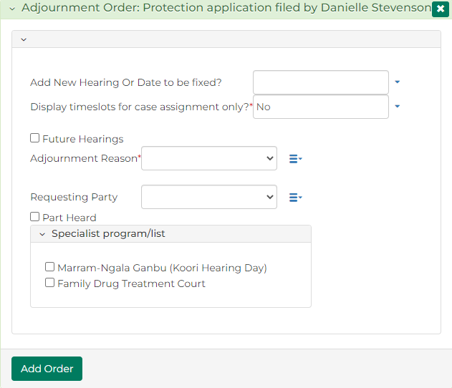

1. Is matter to be adjourned for new hearing date?

|  |  |
| --- | --- |
| If | Then |
| Yes | Go to next step |
| No | Go to step 10 |

1. Complete required panels and fields.

| Panel: Adjournment Order | |
| --- | --- |
| Field: | Action: |
| Add New Hearing or Date to be fixed? | Select: New Hearing |
| Type | Select hearing type.  Note:   * Calendar Assistant displays * Select available date from Calendar Assistant |
| Court Location | Change if required. |
| Case Jurisdiction | - |
| Display timeslots for case assignment only? | Change if required.  Note:   * Field will display Yes if case has been assigned to Judicial Officer * Field will display No if case has not been assigned to Judicial Officer |
| Start Date Time | Do not change. |
| Calendar Recurring Event Widget | Select if required.  Note:  If selected, further fields display. |
| Duration Minutes | Do not change. |
| Future Hearings | Select if required.  Note:  If selected, further fields display. |
| Adjournment Reason | Select adjournment reason. |
| Requesting Party | Select if required. |
| Part Heard | Select if required. |
| Specialist program/list | Select if required. |

1. Is matter to be adjourned to a date to be fixed?

|  |  |
| --- | --- |
| If | Then |
| Yes | Go to next step |
| No | Go to step 12 |

1. Complete required panels and fields.

| Panel: Adjournment Order | |
| --- | --- |
| Field: | Action: |
| Add New Hearing or Date to be fixed? | Select: Date To Be Fixed |
| Display timeslots for case assignment only? | Do not change. |
| Adjournment Reason | Select adjournment reason. |
| Requesting Party | Select requesting party. |
| Part Heard | Select if required. |
| Specialist program/list | Select if required. |

1. Is matter to be listed with an existing hearing?

|  |  |
| --- | --- |
| If | Then |
| Yes | Go to next step |
| No | Go to step 14 |

1. Complete required panels and fields.

| Panel: Adjournment Order | |
| --- | --- |
| Field: | Action: |
| Add New Hearing or Date to be fixed? | Select: List with existing hearing |
| Type | Select type of hearing. |
| Display timeslots for case assignment only? | Change if required.  Note:   * Field will display Yes if case has been assigned to Judicial Officer * Field will display No if case has not been assigned to Judicial Officer |
| Related Hearings | Select relevant option. |
| Future Hearings | Select if required.  Note:  If selected, further fields display. |
| Adjournment Reason | Select adjournment reason. |
| Requesting Party | Select if required. |
| Part Heard | Select if required. |
| Specialist program/list | Select if required. |

1. Click: Add Order

Order Summary displays:

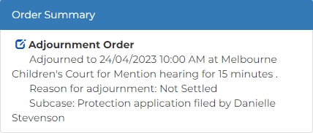

|  |  |
| --- | --- |
|  | Note:  Once all orders are added, click Preview button to review order in more detail. |
|  |  |

1. Is another order required?

|  |  |
| --- | --- |
| If | Then |
| Yes | Add order  Resource:  See Quick Reference Guide: File Minutes of Proposed Orders (Amend, Add or Delete) |
| No | Go to next step |

1. Is Order Summary correct?

|  |  |
| --- | --- |
| If | Then |
| Yes | Go to next step |
| No | Amend order  Resource:  See Quick Reference Guide: File Minutes of Proposed Orders (Amend, Add or Delete) |

1. In Share with parties or submit to court? field, select relevant option.

|  |  |
| --- | --- |
|  | Note:  Share with Parties allows other parties to view and update Minutes of Proposed Orders  Minutes of Proposed Orders cannot be updated once Submit to Court selected |

1. Click: Proceed

Confirmation of Filing screen displays:

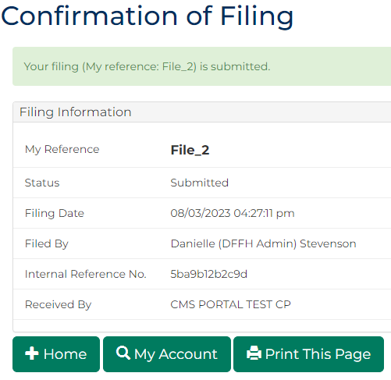

|  |  |
| --- | --- |
|  | Note:  Minutes of Proposed Orders can be updated in Orders tab any time before submission to Court  Once submitted, Minutes of proposed orders document generates and can be accessed through My Account screen |
|  |  |
|  | Resources:  See Quick Reference Guides:   * File Minutes of Proposed Orders (Amend, Add or Delete) * Download document |
|  |  |