View hearings - Lodge adjournment request
Note:
This User Guide covers how to view the hearings on a case also how to lodge an adjournment request on an existing case:
Please see:
For information on retrieving a CMS Portal case you already have access to, please see User Guide: Cases
Step | Action |  | Result
 | Click: Log in |  | The CMS Portal Home screen displays:  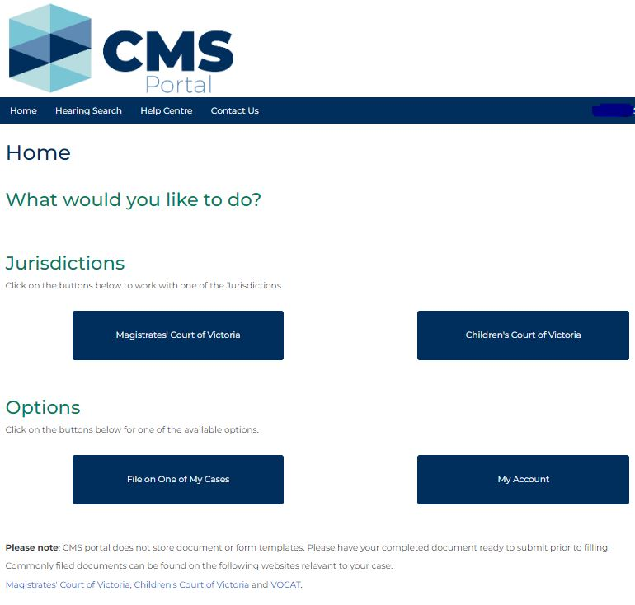
 | Click: File on One of My Cases |  | The Search Case screen displays:  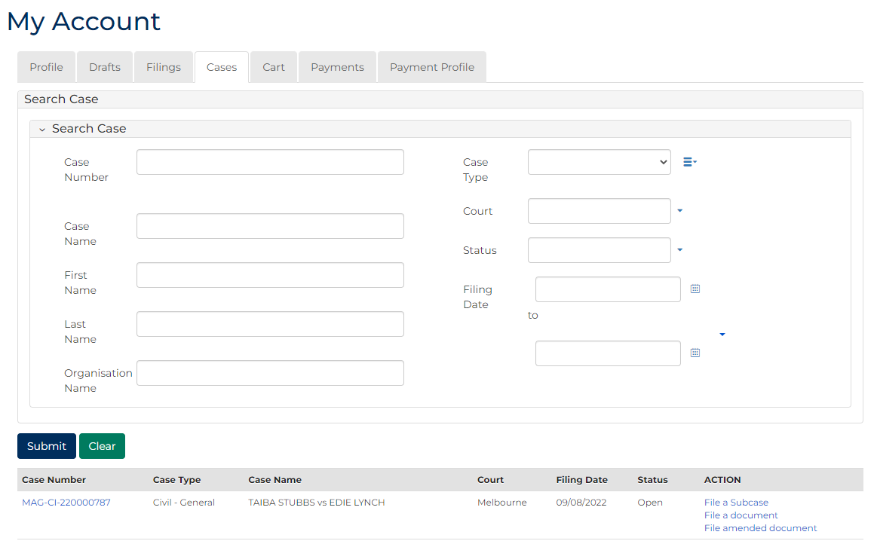
Note:
Cases appear below the case search in My Cases.
 | Click the Case Number link:  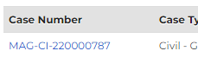 |  | The case displays:  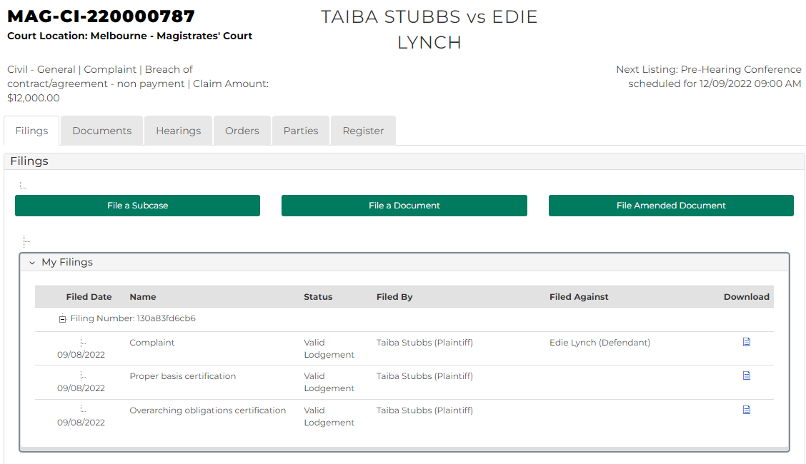
 | Click the Hearings tab:  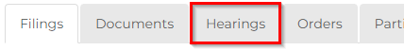 |  | The Case Hearings screen displays:  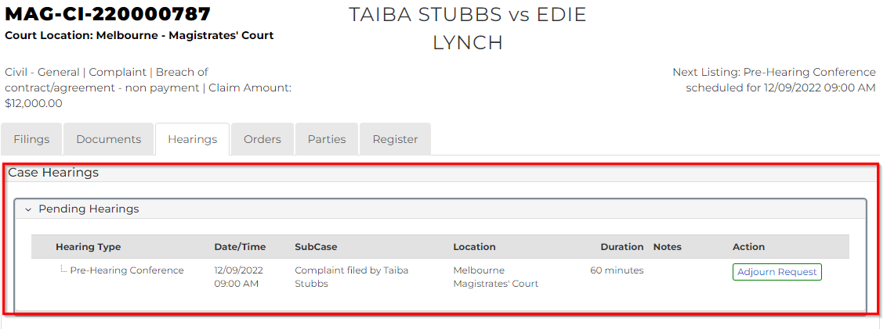
Note:
Displays both pending and finalised hearings in separate panels.
 | If required, select: Adjourn request |  | The Add Adjournment Request screen displays:  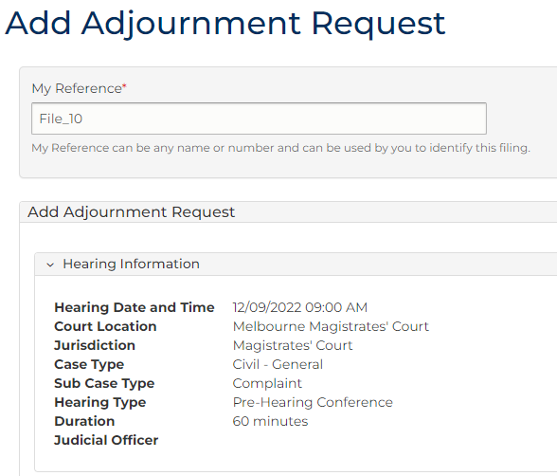
Complete the required panels and fields:
Fields marked with a red asterisk * are mandatory.
PANEL: Case Details
In this field … | Provide this information …
Subcases | Select subcases.
Requesting Parties | Select party who is seeking the adjournment
Consent | Select either: Yes or No
Note:
If selecting No: a sub menu appears which requires the following: Please specify which parties do not consent and why.
Proposed Hearing Type | Displays the current hearing type the matter is listed for.
Event Location | Displays the location where the matter is currently listed.
Proposed date/time | Either:  - Select an option from the Calendar Assistant  OR  - Manually provide a different date and time in the fields using the date and picker tools
Calendar Assistant: Select: Show Slots | Select suitable date radio button
Note:
An error occurs if you don’t make a selection from the available slots now.
Continued …
Continued …
Complete the required panels and fields:
PANEL: Case Details continued
In this field … |  | Provide this information …
Resources |  | Click in the checkbox(s) to select resource(s).
Interpreter |  | Select the party requiring the Interpreter.
Interpreter language |  | Select the required Interpreter language.
Add to Underlying Cases |  | Select or search for case and select checkbox
Adjournment Details |  | Select an Adjournment Reason.
Adjournment Notes |  | Type any required adjournment notes.
Note:
For Civil cases, interpreters are not provided by the court. Interpreter details are only entered if an interpreter is booked for your client and you need to advise the court.

 | Click Proceed |  | The Confirmation of Filing screen displays:  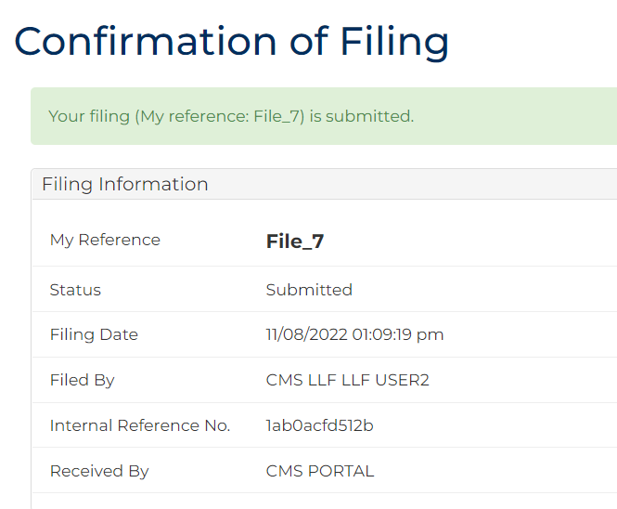
Note:
A confirmation of filing is sent to the Log-in email address.

