View filed document
This User Guide outlines the steps required to view saved or submitted filings.
Part | Page
Part 1: View previously filed document | 1
Part 2: View undelivered documents | 4

Part 1: View previously filed document
Step | Action | Result
 | Log in to the CMS Portal | The CMS Portal home page displays:  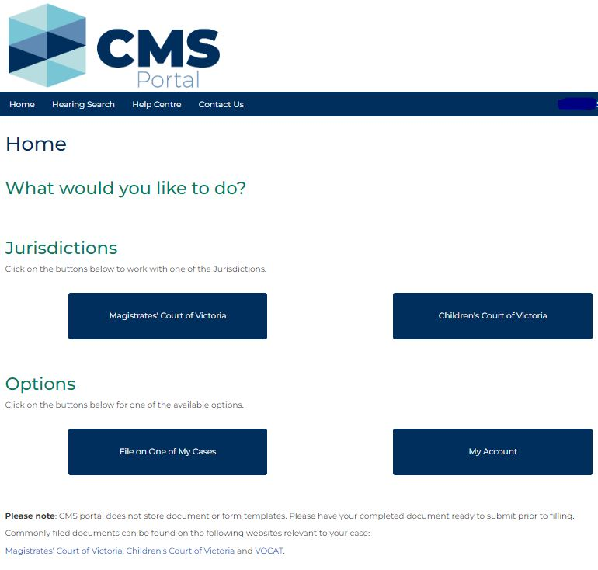
 | Click: My Account  Continued… | The My Account page displays the My Filings tab, containing details of recent filings, including:  - Case/Record Numbers  - Filing Status, and  - Action buttons to view additional case details  Continued…
 | 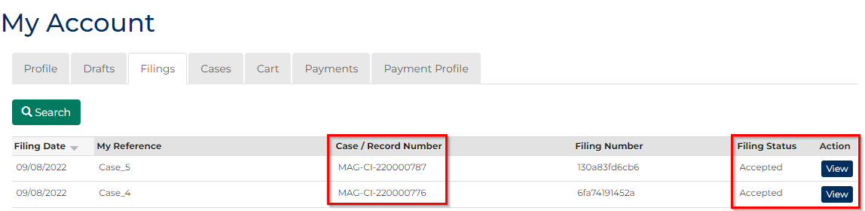
 | In the Action column for the relevant case, click: View | The CMS Portal displays a summary of the case:  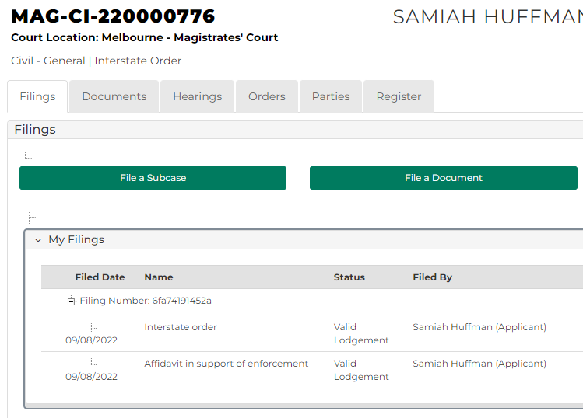
4 | The Filings tab displays details of the filing, including the:  - current status of the filed document, and  - icon to download a copy of the document  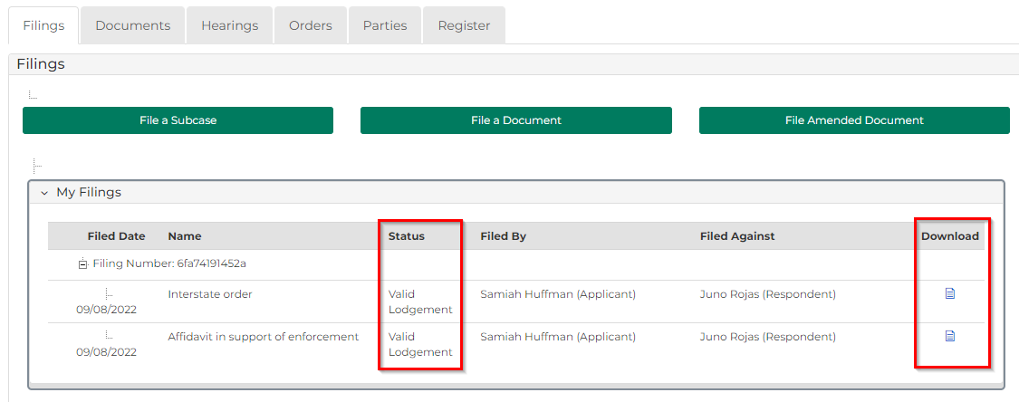

Part 2: View undelivered documents
Step | Action |  | Result
 | Log in to the CMS Portal |  | The CMS Portal home page displays:
 | Click: My Account |  | The My Account page displays the My Filings tab:  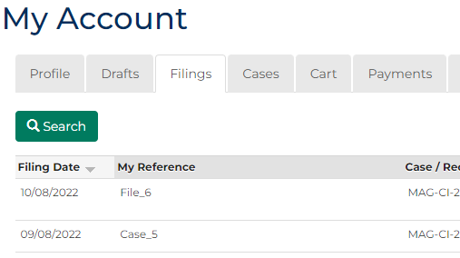
 | Click: Drafts |  | The My Account screen displays the Drafts tab:  Continued…
Continued…
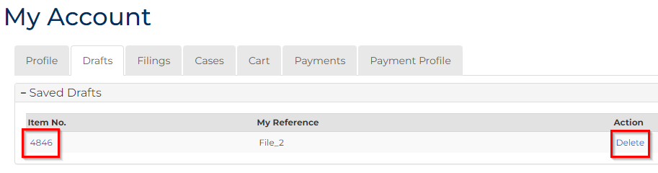
Note:
If your CMS Portal user account does not have any undelivered documents, the Drafts tab displays: No case found
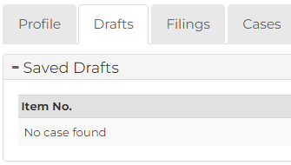
 | OPTIONAL:  To delete documents, from the Drafts tab, in the Action column, click: Delete  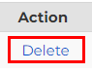 |  | A confirmation message displays.  To proceed with deleting the filing, click: Delete
 | OPTIONAL:  To view undelivered document drafts, from the Drafts tab, in the Item No. column, click the link:  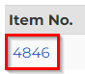 |  | The Filing Details screen displays. Make any necessary changes, then select:  - Proceed, or  - Save for Later  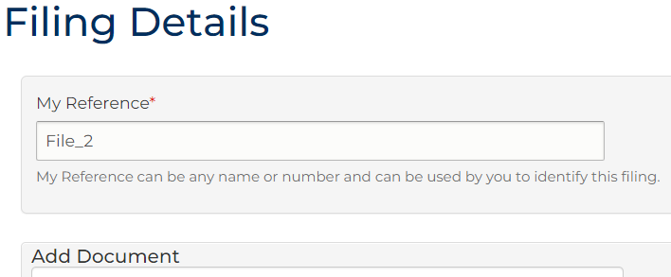
 | 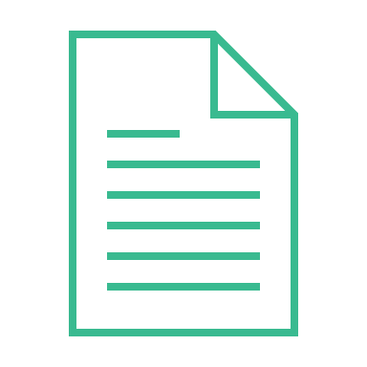 | Please see:  For more information on updating document details, please see the User Guide for the relevant document.

