View and action case
This User Guide outlines the steps required to access a case your organisation already has access to in the CMS Portal.
Please see:
For information on requesting access to a case your organisation does not have access to, please see User Guide: Request Access to a Case

Step | Action | Result
 | Log in to the CMS Portal | The CMS Portal screen displays:  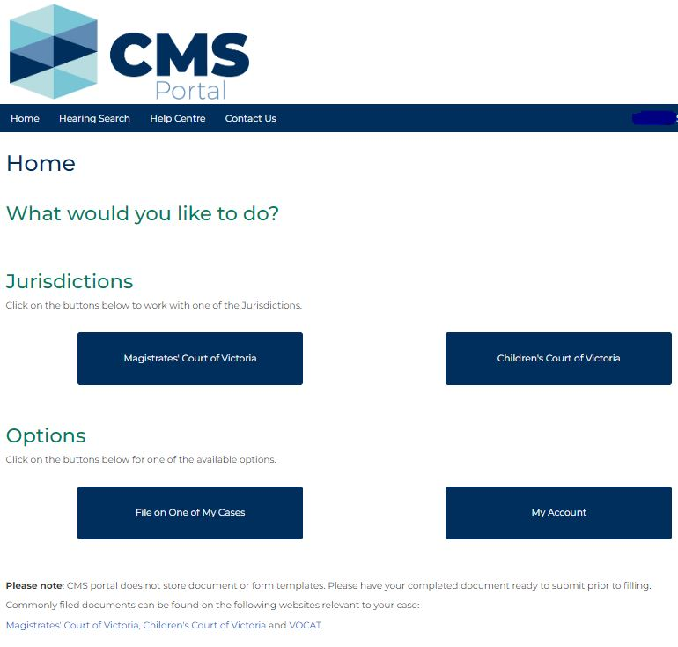
 | Click: My Account | The My Account screen displays:  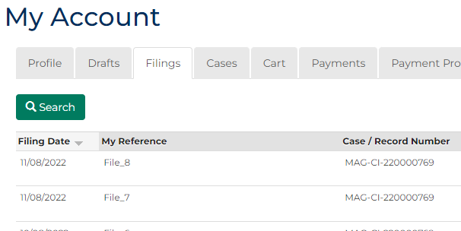

Step | Action |  | Result
 | Click: Cases  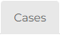 |  | The Search Case screen displays:
 | 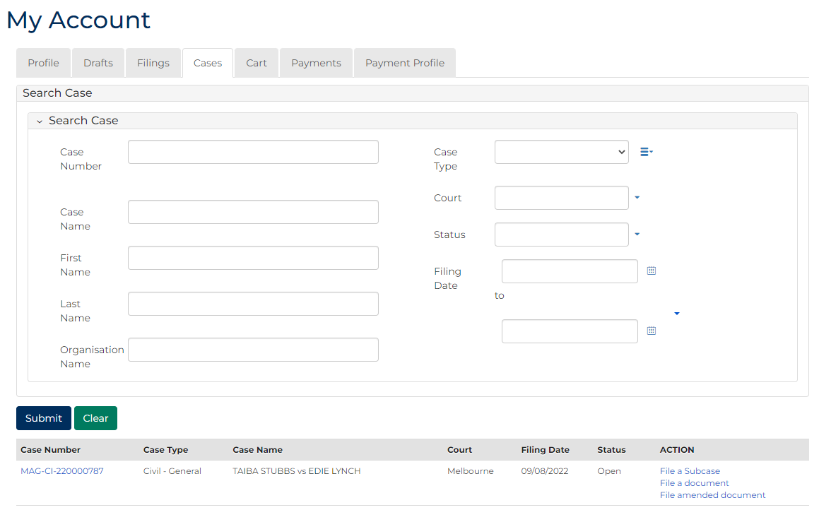
Hint:
A list of cases your CMS Portal account has access to displays at the bottom of the screen. If the relevant case is visible in this list, click the Case Number to access the case, or a link in the Actions column to file on the case.
Complete the required panels and fields:
Fields marked with a red asterisk * are mandatory.
PANEL: Search Case
In this field … | Provide this information …
Case Number | Type the relevant Case Number
Case Name | Type the name of a party in the case.
First Name | Type the First Name of the relevant party.
Last Name | Type the Last Name of the relevant party.
Organisation Name | Type your Organisation Name
Case Type | Select the relevant Case Type
Court | Select the relevant Court
Status | Select the case Status
Filing Date | Click the Calendar icon to select a date window.

 | Click: Submit |  | Cases matching the search criteria display:  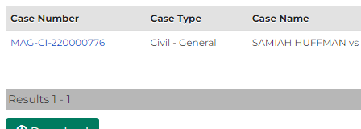
Hint:
If the relevant case does not display in the list of results, adjust the search criteria and click: Submit
To reset all fields, click: Clear
What action is required on the case?
To perform this action … | Click this link ….
Access case details | Click the link for the relevant case in the Case Number column:
File on the case | Click the link for the relevant filing type in the ACTION column:

