Run filings report
Run reports of your organisation's previous filings and case access requests.
Step | Action | Result
 | Log into the CMS Portal | The CMS Portal Home screen displays:  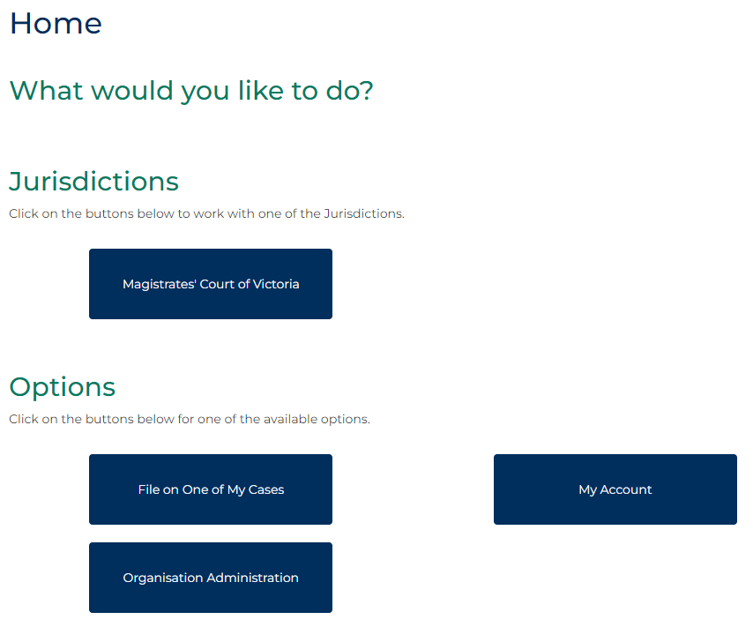
 | Click: Organisational Administration  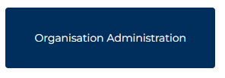 | The Organisational Administration screen displays:  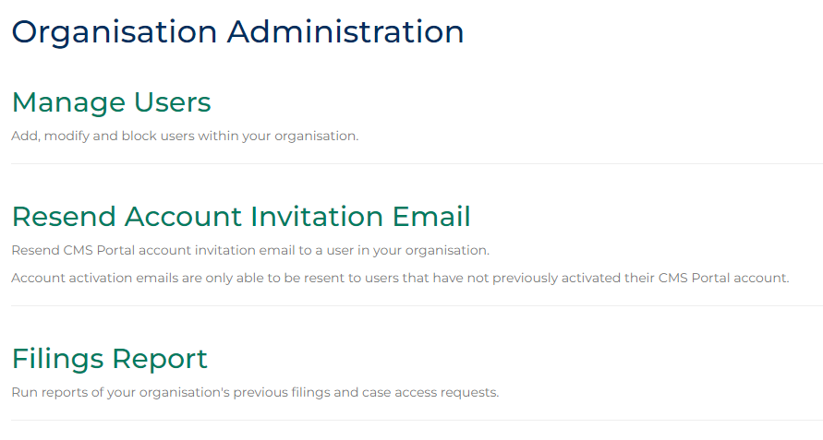
 | Click: Filings Report | The Filings Report screen displays:  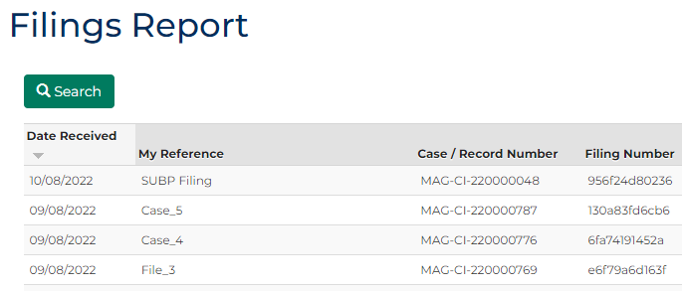
 | Click: Search  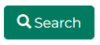 | The Filings Report with panels screen displays:  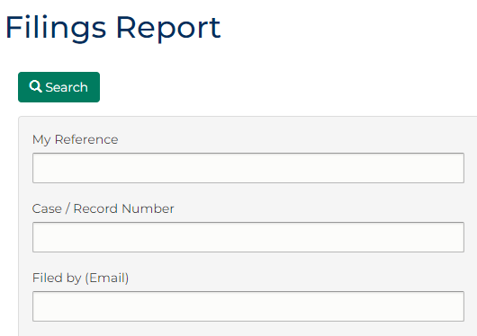
Complete the required panels and fields:
Note:
A Filings report can be sorted by a list of fields, as per table below. Single or multiple fields can be selected.
PANEL: Filings Report
In this field … | Provide this information …
My Reference | Type the case reference assigned to the case.
Case/Record Number | Type the Case/Record number assigned to the case.
Submitted by (Email) | Type the email address of person who submitted the case.
Filing Status | From the menu, select one file status function.
Filing Date From | Select filing date range.
Filing Date To | Select filing date range.

 | Click: Search | The relevant cases appear at the bottom of the screen:  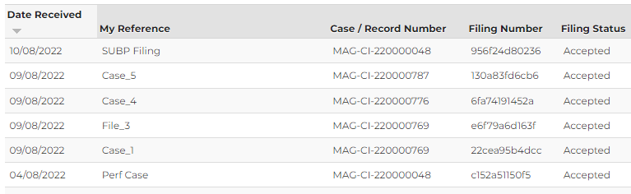
 | Click: Download Results  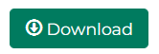 | The Results download as an Excel spreadsheet:  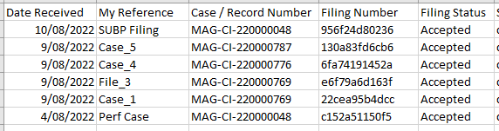
Hint:
Save the file as per your internal processes and naming convention.
Note:
No more than 1000 records can be downloaded at a time.

