Resend account invitation email
Resend CMS Portal account invitation email to a user in your organisation.
Account activation emails are only able to be re-sent to users who have not previously activated their CMS Portal account.

Step | Action |  |  | Result
 | Log in to the CMS Portal |  |  | The CMS Portal home screen displays:  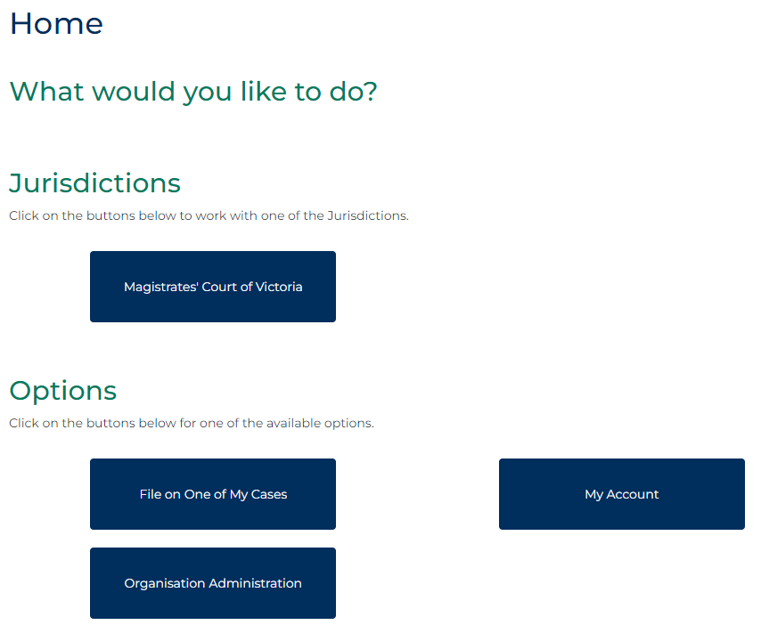
 | Click: Organisation Administration  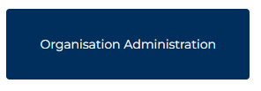 |  |  | The Organisation Administration screen displays:  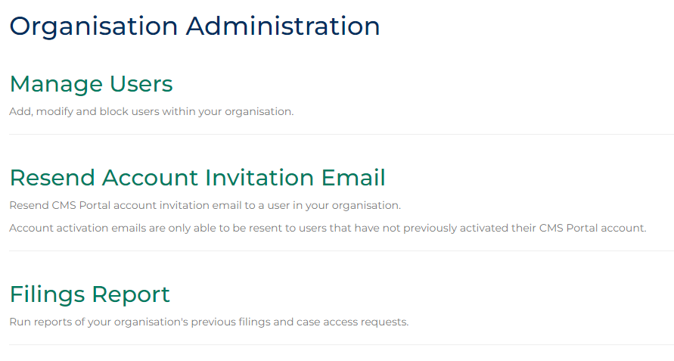
 | Click: Resend Account Invitation Email  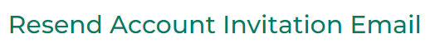 |  |  | The Resend User Activation Email screen displays:  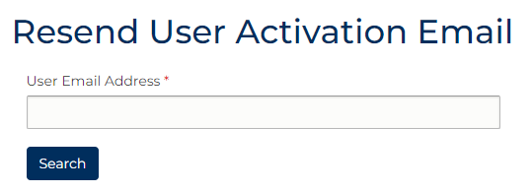
Complete the required panels and fields:
Fields marked with a red asterisk * are mandatory.
PANEL: Resend User Activation Email
In this field … | Provide this information …
User Email Address | Type the email address of the User.

Note:
An error message will display if the User is not from your organisation or has previously activated their account.
 | Click: Search  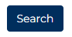 |  |  | A confirmation status message displays Inactive:  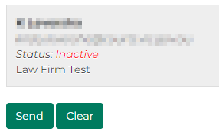
 | Click: Send  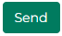 |  |  | A confirmation message displays:
Note:
The user is sent an email notifying them of the account creation, which contains a link the user needs to click to activate their account:
