Navigate My Account screen
This guide includes instructions on how to navigate to the:
• My Account screen in the CMS Portal
• Filings tab and view and download documents
• Profile tab to make changes to your user profile
• Payments tab to view payments
• Cart tab to view/action undelivered documents (if applicable)

Step | Action |  |  |  | Result
 | Log into the CMS Portal |  |  |  | The CMS Portal Home screen displays:  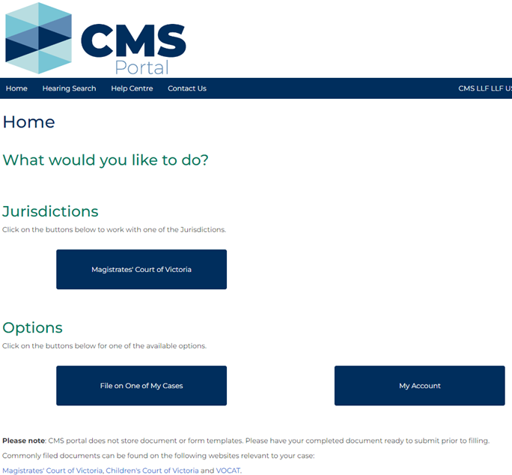
 | Click: My Account |  |  |  | The My Account screen displays and defaults to the Filings tab:  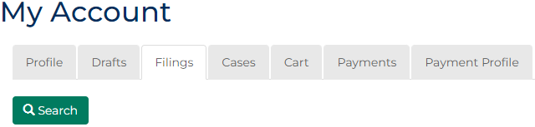
The Filings tab displays:
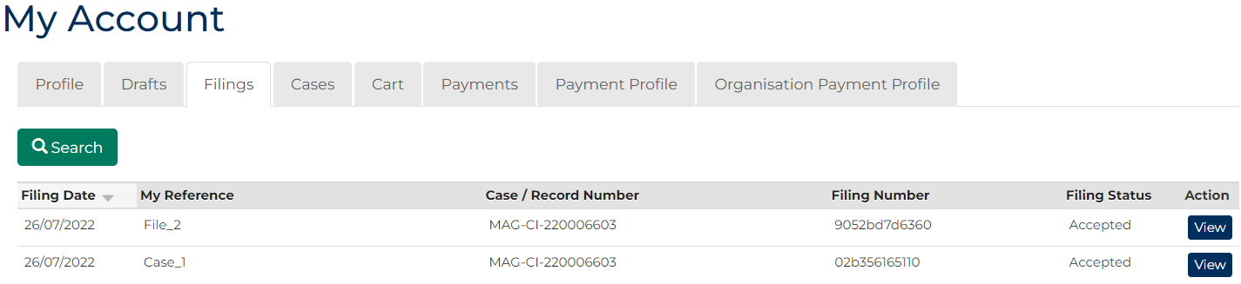

 | Click View for filing information: |  |  |  | The Case Summary screen displays:  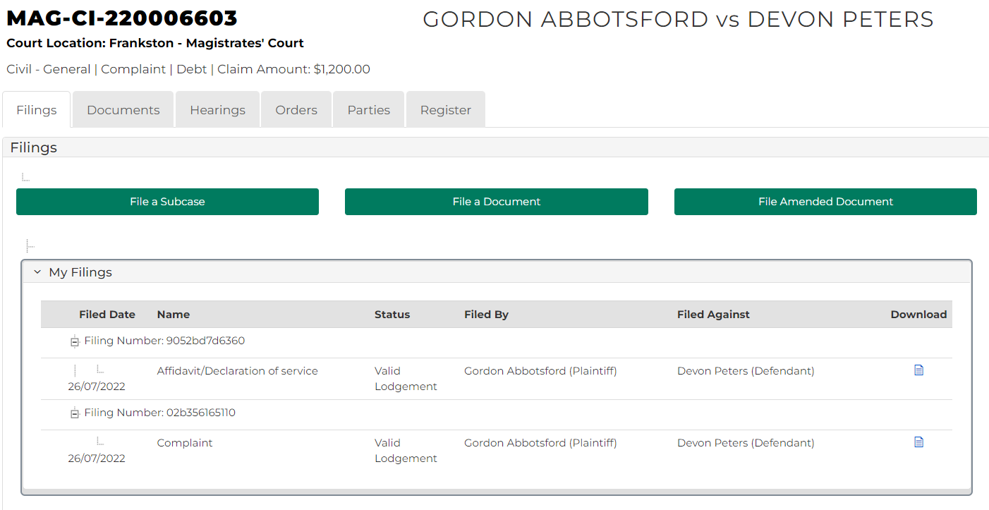
 | Click the Download Document icon for further case information.
 | Click: Profile tab  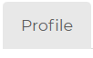 |  |  |  | In the Profile tab, you can add or change your:  - Personal Information  - Email address  - Password  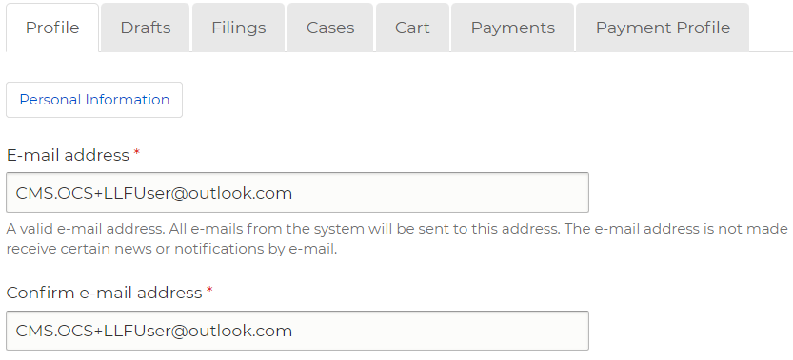
 | Click: Drafts tab  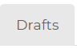 |  |  |  | 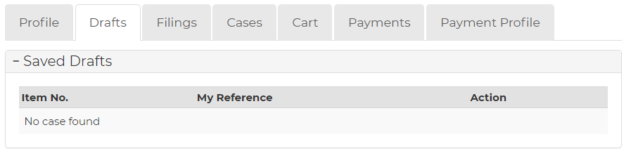  The Drafts tab displays:
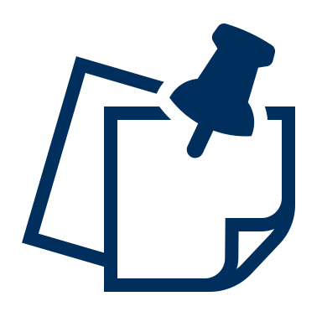 |  |  |  | Note:  This page indicates any saved filings that have NOT been filed.
 | Click: Cases tab  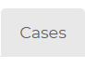 |  |  |  | The Cases screen displays:  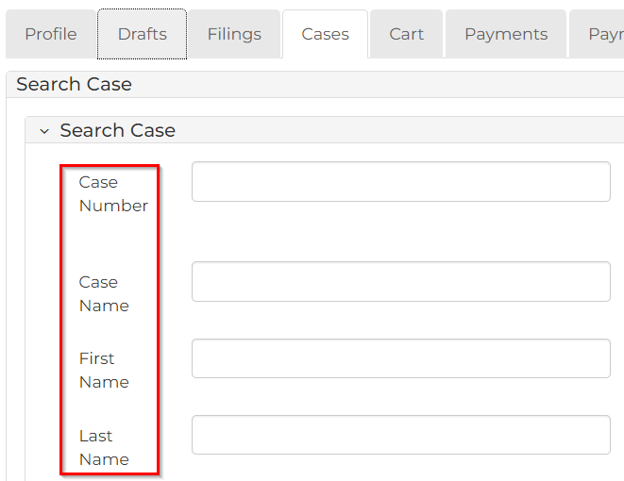
Hint:
This page enables you to search by numerous filter options. The result of your search appears at the bottom of the page.
Note:
A list of cases your CMS Portal account has access to only display. Click the Case Number to access the case, or a link in the Actions column to file on the case.
 | Click: Cart tab to view information on undelivered documents:  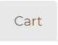 |  |  |  | The Cart screen displays:  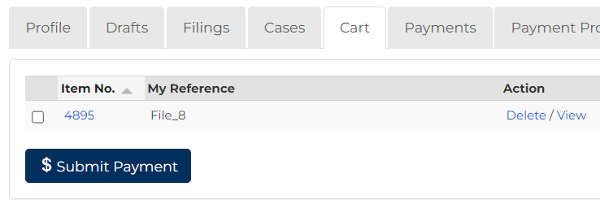
 | To delete or view documents, tick the box next to the document. |  |  |  | 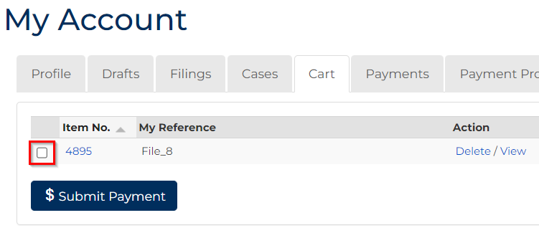
 | To submit payment for a document/s tick the box next to the document/s and click the Submit Payment button.  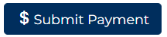 |  |  |  | The Process Payment screen displays:  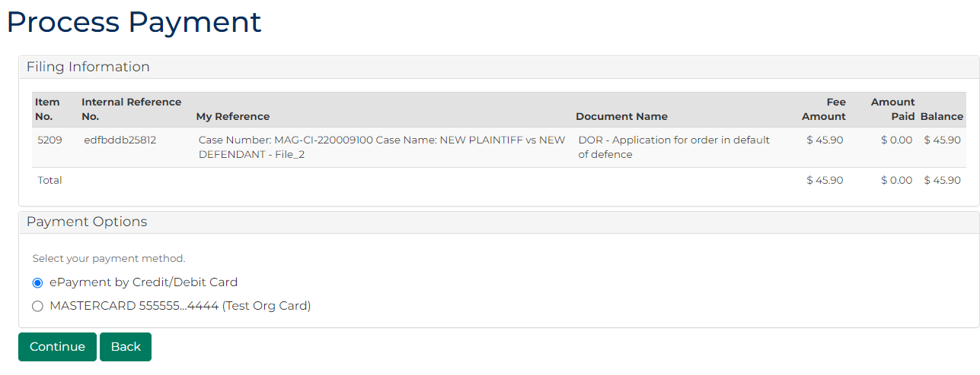
 | Click: Payments tab to view payment information  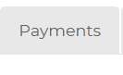 |  |  |  | The Payments page displays:  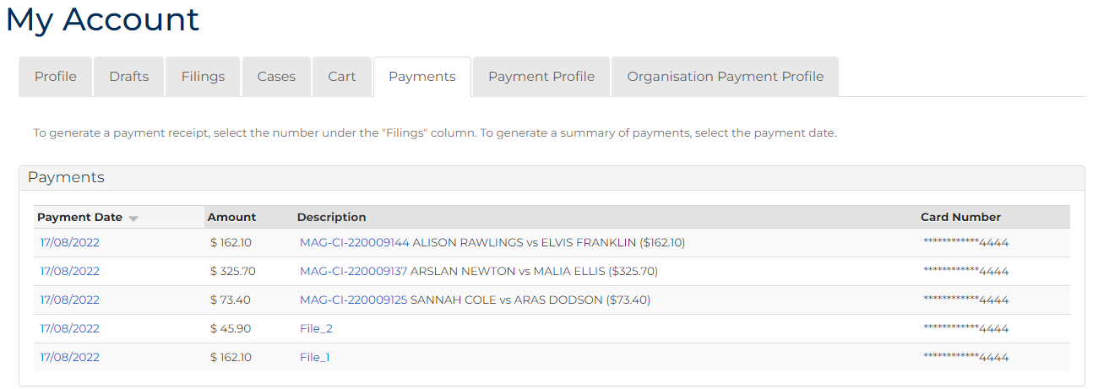
 |  |  | Note:  On this page, you can view:  - Payment date  - Amount |  |  | - Filings  - Card number (only the last four digits)
 | Click: Payment Profile tab  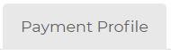 |  |  |  | The Payment Profile page displays:  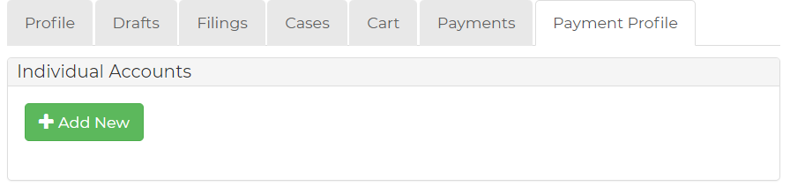
Note:
On this page, you can add credit card payment method details by clicking the +Add new button.

 | Admin User Profile Only  Click: Organisation Payment Profile tab  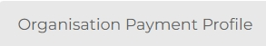 |  |  |  | The Organisation Accounts page displays:  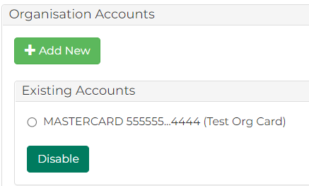
Note:
On this page, you can add credit card payment method details by clicking the +Add new button.
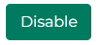
You can disable Existing Accounts by ticking the account number and clicking the Disable button

