Navigate home screen and functionality
This User Guide outlines the actions possible from the CMS Portal Home page, including:
- Accessing jurisdictions connected to the CMS Portal to:
Commence a new case, or
Request access to an existing case you’re a party to
- Filing on an existing case
- View your cases and access documents and information on these cases.

Step | Action |  | Result
 | Log into the CMS Portal |  | The CMS Portal screen displays:  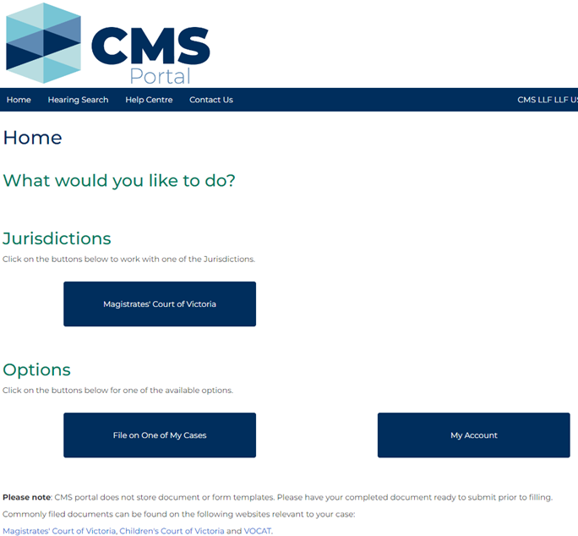
 | Navigate to the top of the main screen of the CMS Portal Home page: |  | The CMS Portal screen displays:  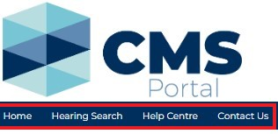  Continued …
Continued …
CMS Portal main navigation menu
Click this … | For this information …
Home | Return to the Home page after navigating to a different screen.
Hearing Search | Search for any hearings currently listed in the CMS
Note:
Only hearings for case types that have been integrated with the CMS Portal will display on this screen. Continue to check EFAS if the relevant case type has not been deployed in the CMS yet.
Help Centre | Online support for external parties using CMS Portal. This includes quick reference guides and frequently asked questions.
Contact Us | Contact information for technical support for CMS Portal and who to go to for procedural support.
Note:
The CMS Support team cannot provide advice, comment on court or tribunal matters or answer legal questions.

 | Navigate the Jurisdictions section of the CMS Portal Home page: | The CMS Portal screen displays:  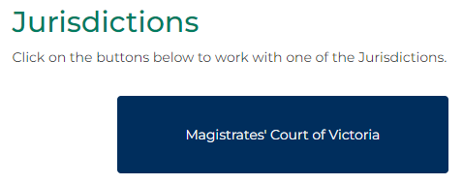
Continued …
Continued ….
CMS Portal Jurisdictions section
Step | Action
 | Select the relevant Jurisdiction. For example:
 | Select the relevant Case Type. For example:
Note:
Additional Jurisdictions and Case Types will be added to the CMS Portal in future deployments.
 | The menu for the selected Case Type displays:
 | Click the button for the desired activity.
Please see:
For additional supporting material to complete these processes, please see the relevant User Guide.

Step | Action | Result
Navigate the Options buttons on the CMS Portal Home page:
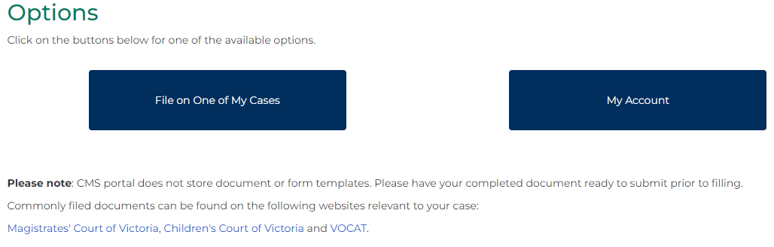

CMS Portal Options buttons
Click this … | For this action …
File on One of My Cases | File on a case you already have access to in the CMS Portal
Please see:
For more information, please see User Guide:
- Filing a document to an existing case, or
- Filing a subcase on an existing case, or
- File an amended document
My Account | Access activity related to your account, including drafted or filed documents, cases and hearing details.
Please see:
For more information, please see User Guide: My account features

