File new case - civil application process (preliminary discovery)
Note:
At any stage before a civil application is filed you may click: Save for Later to save a draft of the complaint.
The draft complaint can be retrieved from the Drafts tab on the My Account screen of the CMS Portal.

Step | Action |  |  | Result
 | Log into the CMS Portal |  |  | The CMS Portal screen displays:  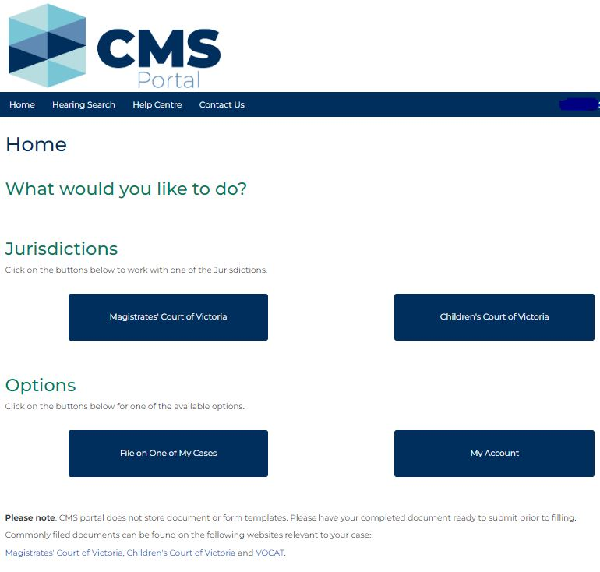
 | In the Jurisdictions section, click: Magistrates’ Court of Victoria |  |  | The Select a Case Type screen displays:  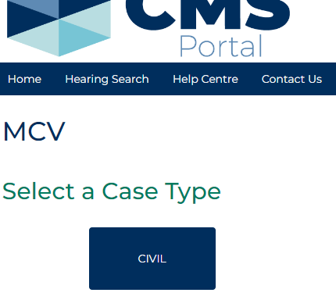
 | Click: CIVIL |  |  | The Civil screen displays:  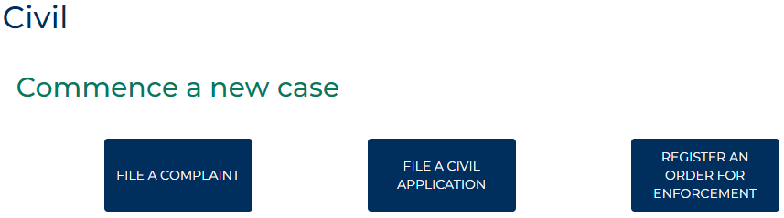
 | Click: FILE A CIVIL APPLICATION |  |  | The Civil Applications screen displays:  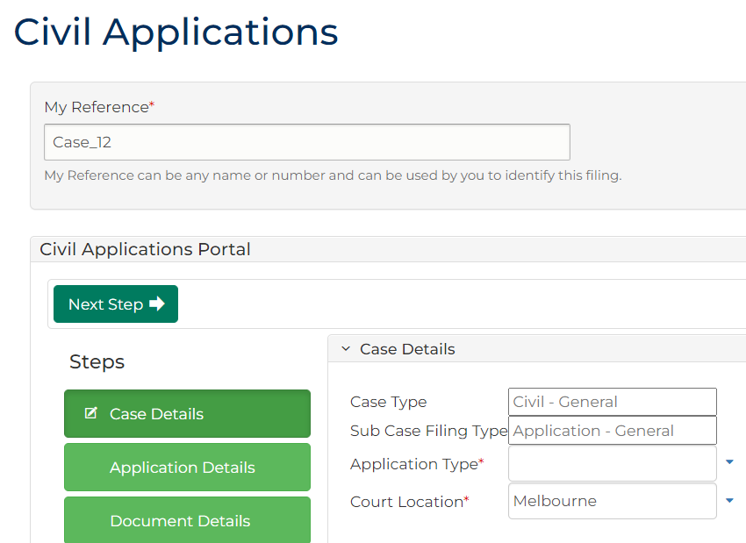
Complete the required panels and fields:
Fields marked with a red asterisk * are mandatory.
PANEL: My Reference
In this panel … | Provide this information …
My Reference | Reference field unique to the filing. Displays a system generated reference. Can be replaced by any reference useful for plaintiff or legal representation to locate and identify the filing.
PANEL: Case Details
Case Type | Displays the case type.
Sub Case Filing Type | Displays the sub case filing type.
Application Type | Select: Preliminary discovery
Court Location | Displays the Court Location based on your user profile settings. Change if required.

 | Click: Next Step |  |  | The Applicant Details panel displays:  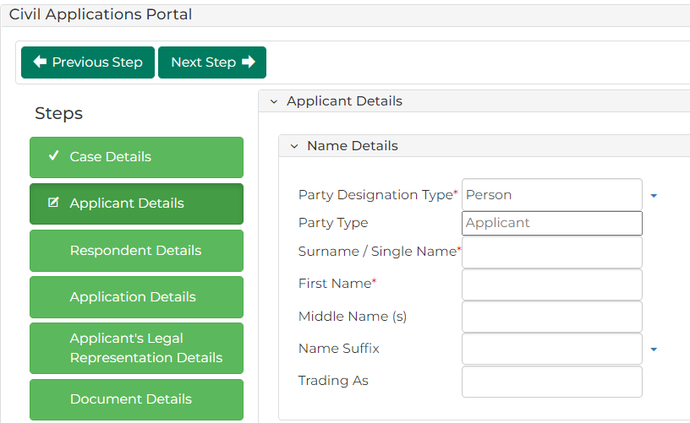
Hint:
Alternatively, click the relevant green heading tile to proceed to the desired section.
Complete the required panels and fields:
PANEL: Name Details
In this field … | Provide this information …
Party Designation Type | Select the type of applicant making the claim.
Note:
Fields change depending on the selected Party Designation Type.
Party Type | Displays: Applicant
Surname/Single Name | Type the surname of the applicant.
First Name | Type the first name of the applicant.
Middle Name(s) | Type any middle names of the applicant.
Name Suffix | Select if required, can be left blank.
Trading As | If relevant, type the trading name of the applicant.
PANEL: Address Details
Address Type | Select the address type.
Physical Address | Start typing the address and select the relevant option from the results.
Continued ….
Continued …
Note:
If the desired address is not displayed with the search feature, type each component of the address in the relevant fields.
ADDITIONAL PANELS
In this panel … |  | Provide this information …
Applicant Contact Details |  | Type the contact details for the applicant into the relevant fields. You do not need to complete all fields.
Financial Details |  | Type the financial details for the applicant, if applicable.
Identification Details |  | Type the Australian Business Number (ABN) of the applicant, if applicable.
Representation Capacity or Litigation Guardian |  | Menus display No. Change if required.

 | Click: Next Step |  |  | The Respondent Details panel displays:  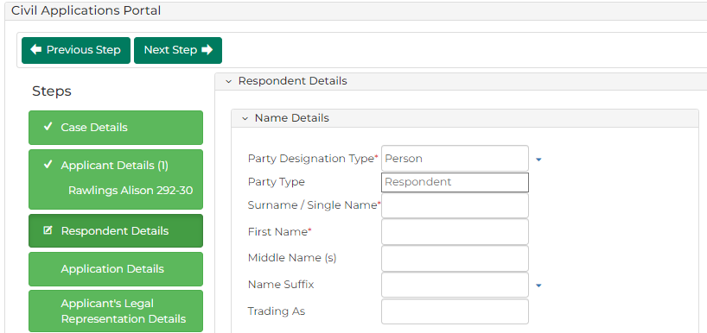
Complete the required panels and fields:
PANEL: Name Details
In this field … | Provide this information …
Party Designation Type | Select the type of applicant making the claim.
Note:
Fields change depending on the selected Party Designation Type.
Party Type | Displays: Applicant
Continued ….
Continued ….
Surname/Single Name | Type the surname of the applicant.
First Name | Type the first name of the applicant.
Middle Name(s) | Type any middle names of the applicant.
Name Suffix | Select if required, can be left blank.
Trading As | If relevant, type the trading name of the applicant.
PANEL: Address Details
Address Type | Select the address type.
Physical Address | Start typing the address and select the relevant option from the results.
PANEL: Identification Details
Australian Business Number (ABN) | Type the ABN of the applicant, if applicable.

 | Click: Next Step |  |  | The Application Details panel displays:  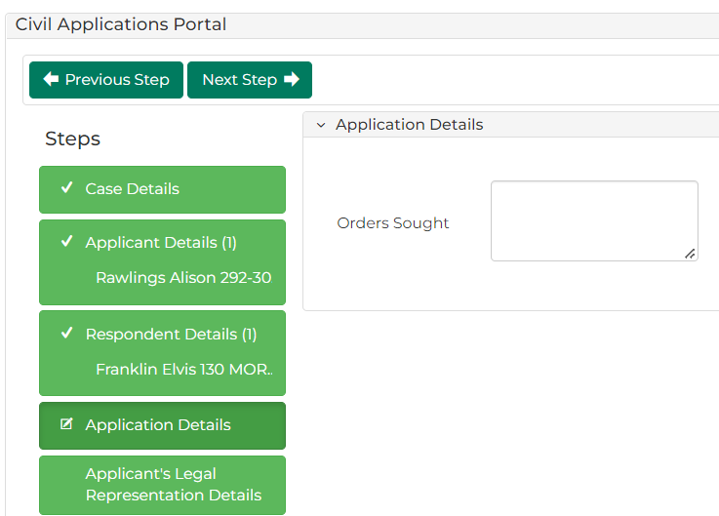
 | In the Orders Sought field, type the orders sought by the application.  Click: Next Step |  |  | The Applicant’s Legal Representation Details panel displays:  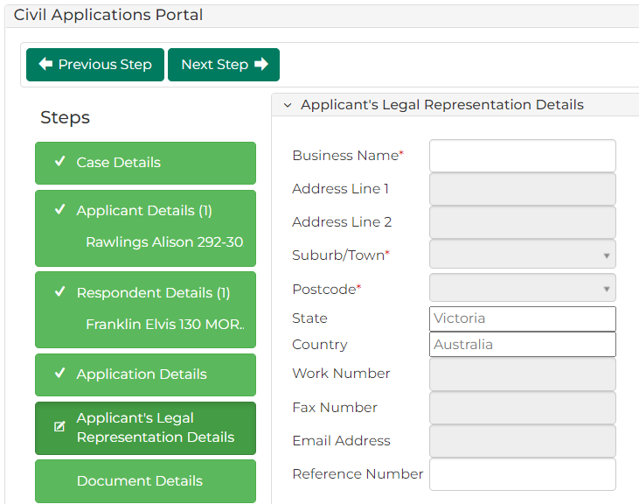
Complete the required panels and fields:
PANEL: Applicant’s Legal Representation Details
In this field … | Provide this information …
Business Name or Solicitor Code | Begin typing the business name and select the relevant option from the results', with something like:  'Begin typing your solicitor code OR type the name of your business, then select the relevant office you are filing on behalf of.
Hint:
The results are drawn from the legal businesses linked to your CMS Portal account.
Reference Number | Optional field to add a reference number associated to the legal representation. This number applies to the entire case and is visible on the Parties tab when viewing a case.
Please See:
For more information regarding viewing details of individual cases and the My Account menu, please see User Guide: My account features

 | Click: Next Step |  |  | The Document Details screen displays:  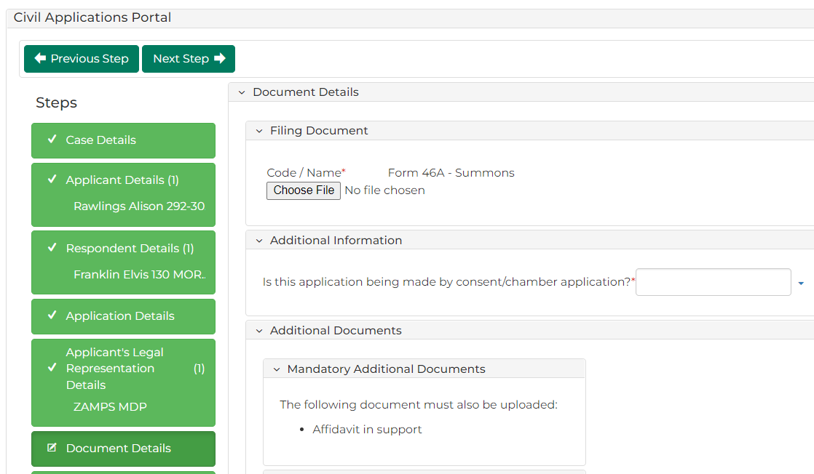
Complete the required panels and fields:
PANEL: Document Details
In this field … | Provide this information …
Filing Document | Form 46A – Summons displays under Code/Name.  Click: Choose File and upload the relevant PDF.
Is the application being made by consent/ chambers application? | Select: Yes or No
Note:
If Yes is selected, a hearing does not need to be added in the next section.
PANEL: Additional Documents
Mandatory Additional Documents | Required documents that can be submitted are listed.
Optional Additional Documents | Required documents that can be submitted are listed.
PANEL: File Document
Code/Name | Start typing the name of the Code/Name and select from the results shown.  If you are unsure of the document Code/Name, click the magnifying glass icon to open the search menu.
Choose File (Displays when Code/Name completed) | Click and add the required PDF document to the case.
Important:
The Affidavit in Support document must be uploaded.
Hint:
Select Add Another Document to upload the optional documents.

 | Click: Next Step |  |  | The Hearing Details screen displays:  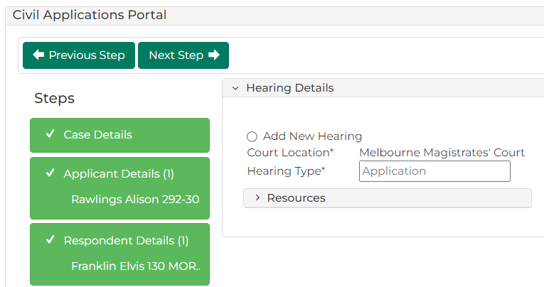
Note:
If you selected an application by consent/in chamber, the hearings tab is not applicable. Proceed to step 18.
 | Select Add New Hearing |  |  | The Hearing Details panel displays additional fields:  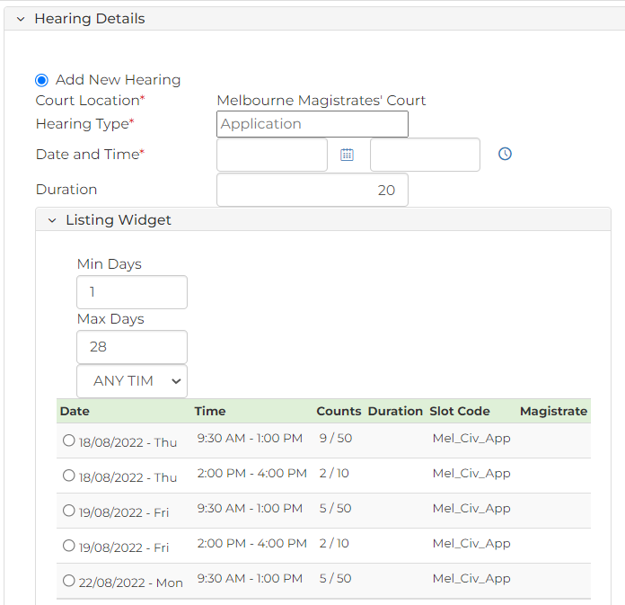
 | Select the desired hearing time. |  |  | 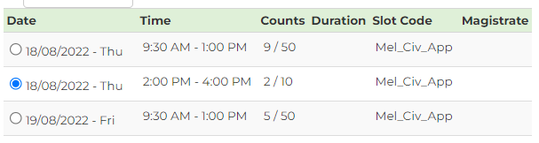
Please See:
For more information on how to manage hearings and listings, please see User Guide: Hearings and Listings
 | Click: Next Step |  |  | The Fee Waiver screen displays:  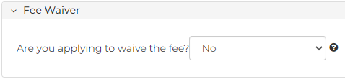
 | From the ‘Are you applying to waive the fee?’ menu, select Yes or No |  |  | If you have selected Yes, information related to the fee waiver displays, including an upload field for the fee waiver application.
Note:
If you select Yes to fee waiver, go to Step 24.
 | Click: Proceed |  |  | The My Account screen displays:  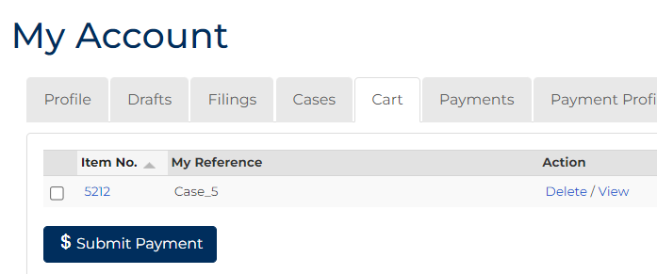
Hint:
To return to previous sections before completing the civil application process, click the green button for the desired section, or the Previous Step button.
 | Select the item requiring payment then click: Submit Payment |  |  | The Process Payment screen displays:  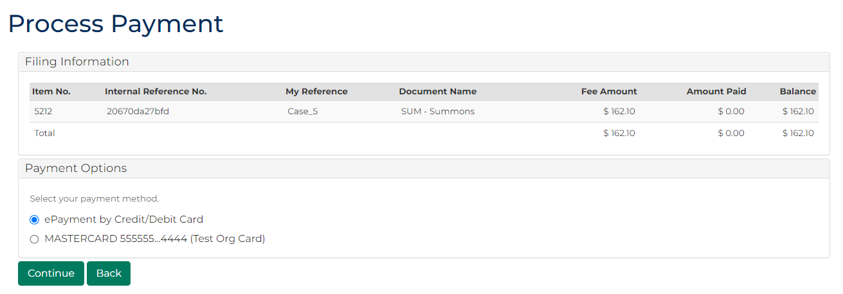
From the Payment Options panel,
select a payment method, then click: Continue
Please See:
Payment options can be added and removed from the My Account screen. For more information, please see User Guide: My account features
What payment method was selected?
If … | Then …
ePayment by Credit/Debit Card | The Payment Processing screen displays.  Enter payment details then select: Make Payment
A stored credit card on your account | Proceed to the next step.

 | The civil application is filed. |  |  |  | The Confirmation of Filing screen displays:  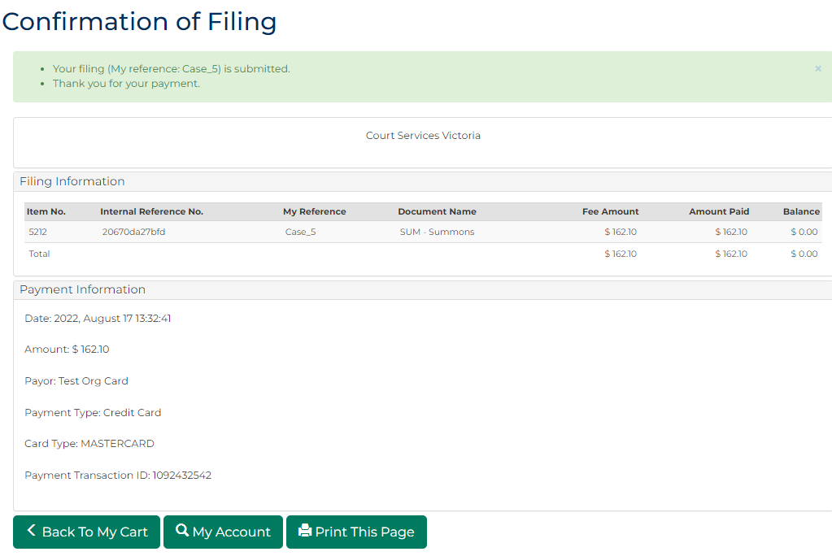
Note:
An email confirmation is sent to the email address associated to your CMS Portal account.

